Življenje v rimskem mestu
Oglej si slike, prisluhni razlagi ter vnesi manjkajoče podatke o vsakem od rimskih gradbenih dosežkov na sliki: Zapiši pod a) kaj slika predstavlja, b) čemu je »zgradba« služila, c) morebitne zanimivosti).
a)__________________________________ b)__________________________________ c)___________________________________________________________________________________________________________________________
_________________________________________

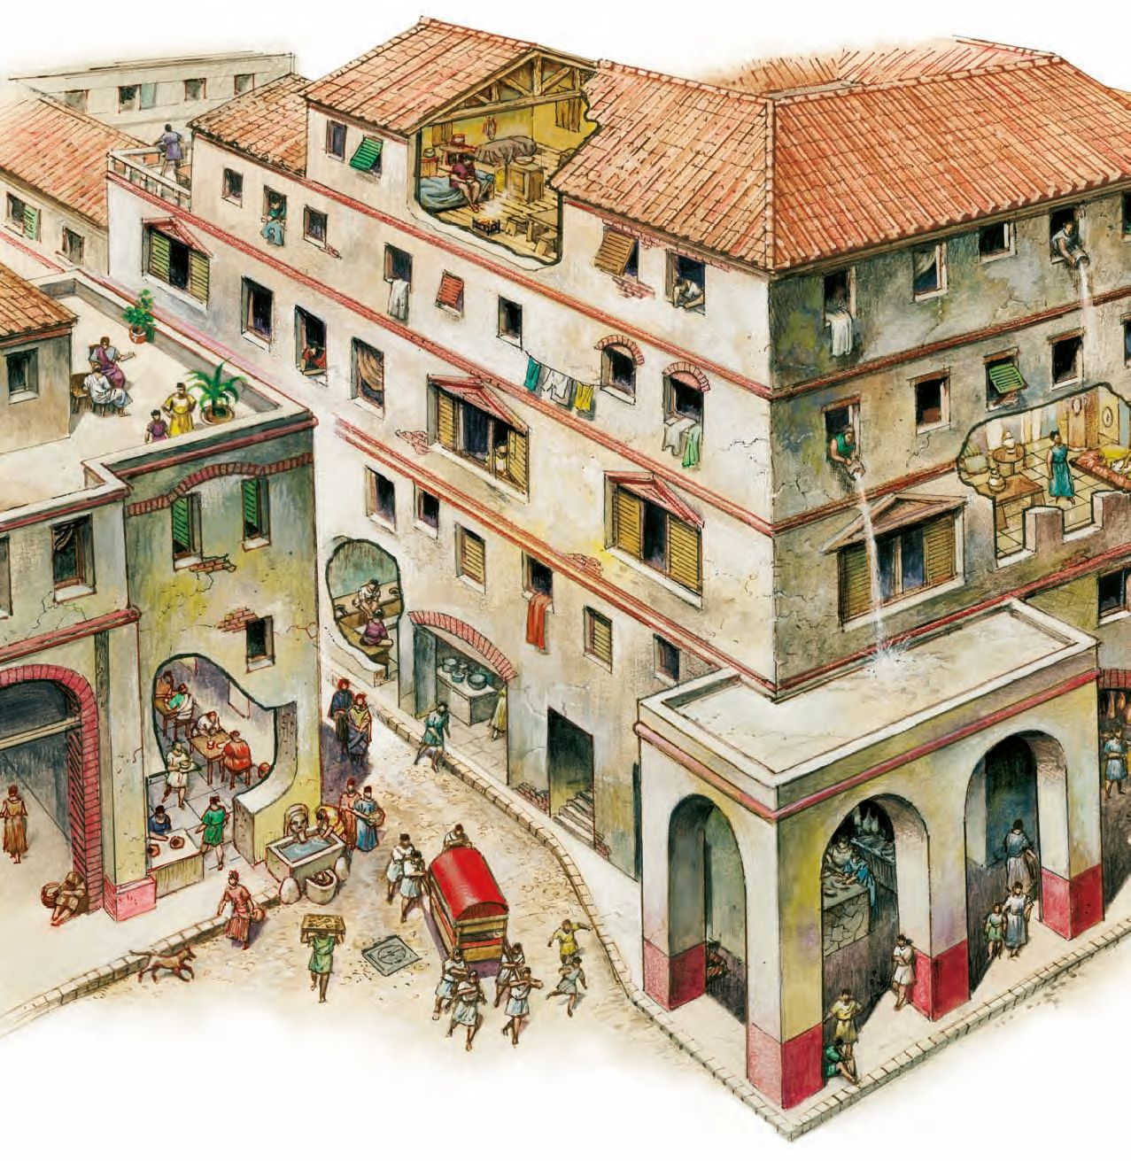

a)_____________________________ b)_____________________________c)___________________________________________________________

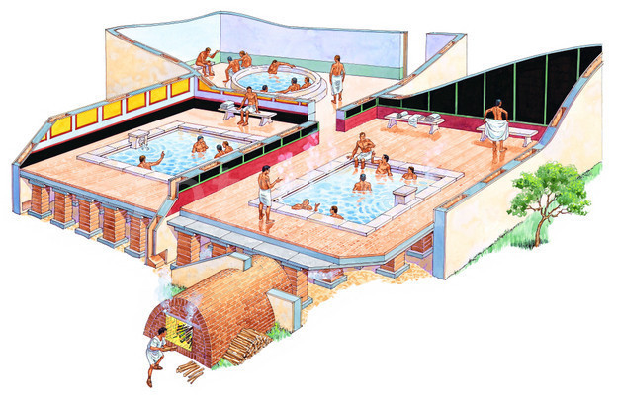

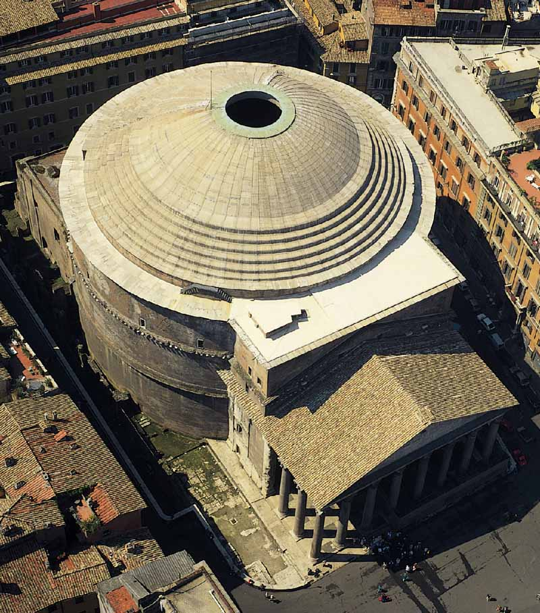
a)_________________________________________ b)_________________________________________ c)_______________________________________________________________________________________________________________________________

a)_______________________________________ b)_______________________________________c)_______________________________________________________________________________

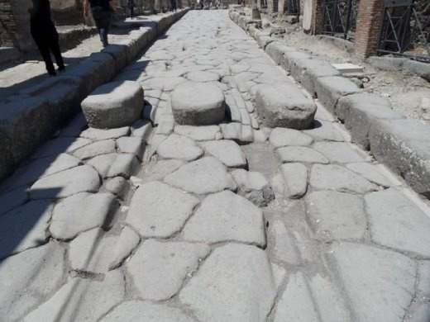

a)_______________________________ b)_______________________________c)_________________________________________________________________________________________________

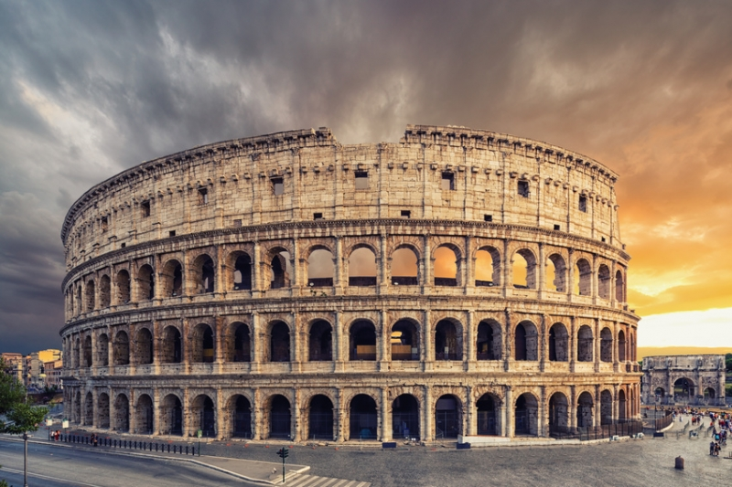

a)_____________________________________ b)_____________________________________c)___________________________________________________________________________________________________________________

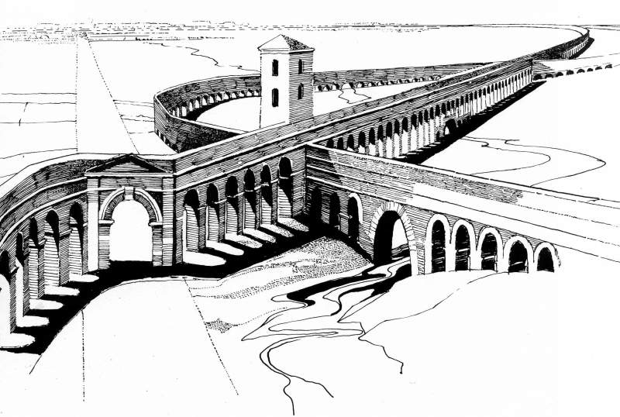

a)____________________________________ b)____________________________________c)________________________________________________________________________________________________________________

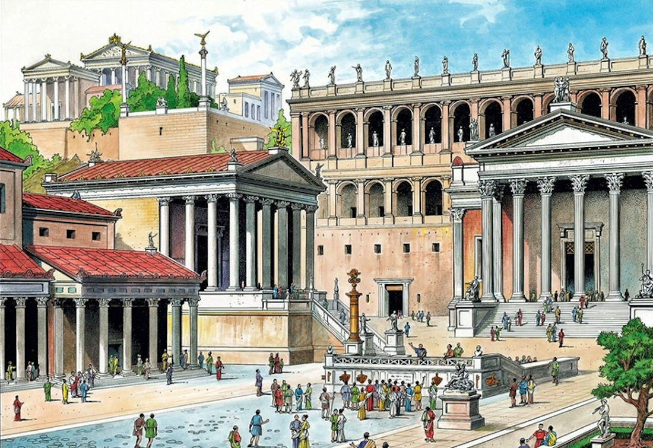

a)___________________________________ b)___________________________________c)__________________________________________________________________________________________________________________________________________________

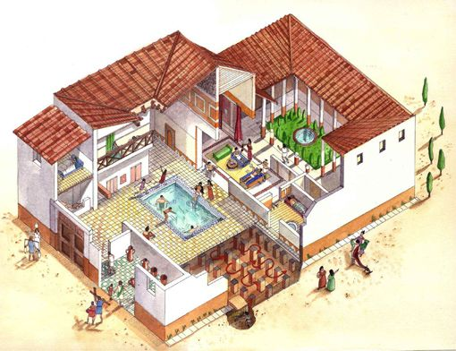

a)__________________________________ b)__________________________________c)__________________________________________________________________________________________________________
