Telling the time
- numbers:
• 1 – one  7 – seven
 2 – two  8 – eight
 3 – three  9 – nine
 4 – four  10 – ten
 5 – five  11 – eleven
 6 – six  12 – twelve
- hours:
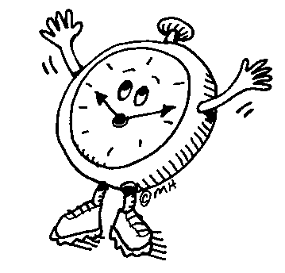

It’s nine o’clock

It’s half past eight

It’s quarter to eight

It’s quarter past two

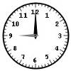
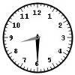
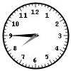
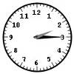

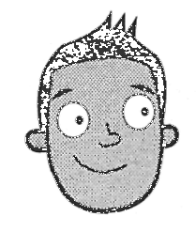
- telling the time:
I eat lunch
at quarter past two.
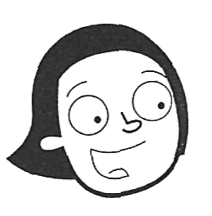
I get up at 7 o’clock./
I get up at 7a.m.

Ura je poldan – it's noon/midday.
Ura je polnoč – it's midnight.
p.m. - popoldan
a.m. - dopoldan

