**LAŽJE NALOGE**

Prebrali boste besedila in mi vaše odgovore posredovali kar v email sporočilu. (do 17.4.)

Poleg tega boste do konca tega ali pa naslednjega tedna (do 24.4.) napisali še spis in mi ga poslali. Naloge pošiljajte in če imate kakšne težave, pišite na [irena.scek@os-sturje.si](mailto:irena.scek@os-sturje.si)

1. naloga

**Dopolni besedilo z manjkajočimi besedami iz okvirčka. Črke izbranih besed vpiši v razpredelnico. Tri besede so odveč. Glej primer 0, ki je že rešen.**

**Rešitve zapiši v email sporočilo tako:** Camp Green Cove: 0 – C, 1 –

CAMP GREEN COVE



|  |
| --- |
| It's opening day at Camp Green Cove in North Carolina. Girls are arriving from all over the **(0)** __**C**_. They spend some time in the mountains. Experienced campers jump out of cars with their old suitcases. They **(1)** ___ and laugh happily when they see old friends. But the **(2)** ___ campers don’t know what to expect. The leaders welcome them warmly and show them around the camp.  Three weeks pass quickly. On the last **(3)** ___ at the camp, everyone gathers around the campfire. They sing songs and tell adventure stories before they go to bed. You can't tell the old campers from the ones that are here for the first time. Each one is now a Green Cove Girl! They **(4)** ___ to the camp, and always will.  What can you look forward to at Green Cove? Singing songs about everything. You sing at meals, after meals, at the campfire, and sometimes for no good reason at all. But you also have to make a **(5)** ___ which activities you do every day.  Everybody at the camp is cool! Four or five girls live in a wooden **(6)** ___ with one leader. The leader helps them when they feel **(7)** ___ and miss their parents and friends. The campers **(8)** ___ good and bad times. They play, and are scared and brave together. Some of them stay best friends for life. |

*(8 točk)*

|  |  |  |  |  |  |  |  |  |  |
| --- | --- | --- | --- | --- | --- | --- | --- | --- | --- |
| 0. |  | 1. | 2. | 3. | 4. | 5. | 6. | 7. | 8. |
| ***C*** |  |  |  |  |  |  |  |  |  |

**BESEDIŠČE**

**2. naloga**

**Preberi besedilo in zapolni vrzeli (1–8) z besedami v okvirčkih. Tri besede so odveč. Na vsako črto prepiši ENO besedo. Glej primer *0*, ki je že rešen.**

**PAZI NA PRAVILEN PREPIS BESED.**

**Rešitve zapiši v email sporočilo tako:** National parks: 0 – trip, 1 –



**NATIONAL PARKS**

There are 385 parks in the national park system in the USA. Every year, more than

200 million people take a (***0***)  *trip*  to the U.S. national parks. They

(**1**) ______________ from all over the world. The Great Smoky Mountains, the Grand

Canyon and Yellowstone are the three parks that attract the most (**2**) ______________.

When you are in a national park in the USA, take a/an (**3**) ______________ look at the

people who work there. Most of the workers are park rangers, but there are many

people who help in the parks but don’t get (**4**) ______________ money for the work

they do. They are called volunteers and they work for free. These people love

(**5**) ______________, as it is their second home. They protect and look after the

(**6**) ______________ national parks. If you like stories about volunteers and others

who work in the parks, maybe it’s time to join them.

It is impossible to see all the parks in a year. That is why you can (**7**) ______________

your virtual visit to the parks at the National Park Service website. Here you can find

an on-line Junior Ranger program for kids of all (**8**) ______________. You can play

more than 50 games and learn about the national parks. If you love your national

parks, monuments and historic sites, this site is for you.

(Prirejeno po: *Time For Kids; www.nps.gov/webrangers*)

|  |  |
| --- | --- |
|  | 8 |

BRALNO RAZUMEVANJE

3. naloga

**Preberi besedilo, kako v Savdski Arabiji preživljajo počitnice. Na podlagi prebranega besedila zapiši KRATKE odgovore. Glej primer 0, ki je že rešen.**

**Rešitve zapiši v email sporočilo tako:** Sandy camping: 0 – In the desert, 1 –

SANDY CAMPING

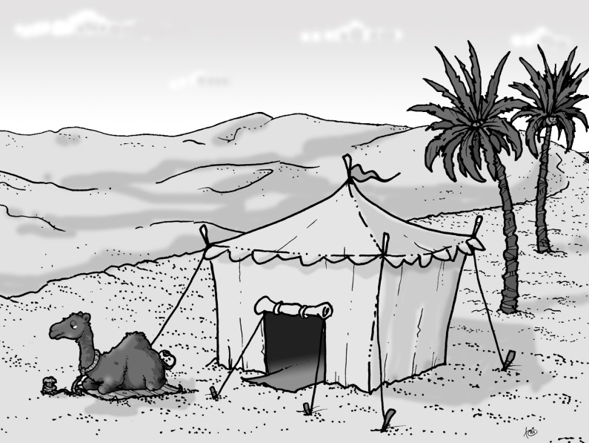

**Campsites in Saudi Arabia**

Saudi Arabia is a country in the Middle East, Asia. Saudis prefer to live in modern cities with houses, stores and coffee shops. When they are on holidays, many families look forward to go camping in the desert far from traffic, crowds, and work or school. They usually leave early in the morning to beat the mid-day heat.

Saudi Arabia doesn't have campsites like America or Europe. Most campsites are a three-hour drive from the city where there are no highways or fast food restaurants for miles. Because there aren't any food stores in the desert, you have to bring everything with you in coolers. The camps don’t offer any swimming pools, showers, playgrounds, or hiking trails.

0 Where do the Saudis put up their tents for their holidays?

***In the desert.***

|  |
| --- |
| 1. How long does it take the Saudis to get to a campsite by car? |

|  |
| --- |
| 2. Where do the Saudis keep their food? |

**Dining in the desert**

A good desert breakfast includes hard-boiled eggs, peanut butter and honey sandwiches, a thick yoghurt, fruit, olives, and tea and milk to drink. Saudis make lunch over a fire pit constructed of a combination of coal and sticks. *Kapsa* is the national dish, and it's their favourite on camping trips. It's made with chicken or lamb, rice, vegetables, and special seasonings. Saudis also enjoy salads with their lunches. Very often, they eat a snack or a dessert of cheesecake or traditional honey cake in the afternoon. At around ten in the evening they enjoy a fine Saudi barbeque. They grill chicken and lamb and on the side they eat salad and a spread made with roasted eggplant and enjoy fruit drinks.

|  |
| --- |
| 3. What do the Saudis use to make a fire? |

|  |
| --- |
| 4. Which meat do the Saudis put in *Kapsa*? |

**Fun in the desert**

Children love camping. Their days are filled with games. Kids shoot marbles, slap down dominoes, and play card games. Everyone loves football. In the evenings, families and friends sit around campfires singing songs. Sometimes, grandparents tell interesting stories of the time when they were children. Saudi Arabia was famous for storytelling in the days before TV and the Internet.

|  |
| --- |
| 5. Where in the camp do the families meet in the evening? |

|  |
| --- |
| 6. What are grandparents’ stories about? |

(Prirejeno po: *Faces*, marec 2013)

*(6 točk)*

**BRALNO RAZUMEVANJE**

**4. naloga**

**Preberi besedilo in ugotovi, ali so trditve v razpredelnici pravilne, napačne ali podatka ni v besedilu. Izbrane rešitve označi s kljukico (√). Glej primer 0, ki je že rešen.**

**Rešitve zapiši v email sporočilo tako:** Skateboarding and R.: 0 – **P**, 1 –

**SKATEBOARDING AND ROLLERBLADING**

If you know how to ice-skate, you can start rollerblading or skateboarding in the summer. It's cheaper than ice-skating, too. You can just skate in the streets or play street hockey in a team. You never get tired of doing it because you're learning to do new things all the time. Another good thing about rollerblading is that it makes you look taller.

[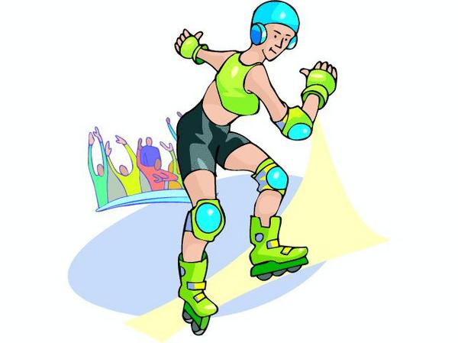](http://www.barrysclipart.com/barrysclipart.com/showphoto.php?photo=29140&size=big&papass=&sort=1&thecat=189)The main disadvantage in big cities is that there aren't many places to do it. In many local areas, there are tennis courts, cricket pitches and football fields but nothing for rollerblading. A lot of parks don't allow rollerbladers or skateboarders. People think rollerbladers and skateboarders are annoying. They also accuse them of vandalism or graffiti writing.

[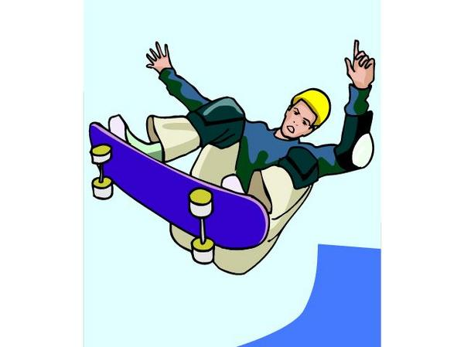](http://www.barrysclipart.com/barrysclipart.com/showphoto.php?photo=26149&size=big&papass=&sort=1&thecat=183)When buying rollerblades, you must be sure they are comfortable. Put on both shoes in the shop. Also, do them up completely. This is to make sure that they do not hurt your feet and toes. Remember to buy the correct type of wheels. You need hard wheels for inside, soft wheels for outside. For a mixture of both inside and outside, you need soft wheels. You might need to replace parts of your boots, therefore it is better to buy a well-known make.

Skateboarding and rollerblading are dangerous, but not too dangerous. The best part is learning new tricks. When someone does a new trick successfully without falling, they are extremely pleased with themselves. People spend days trying again and again to do a new trick. It's a great feeling when they do it.

The two worst things about skateboarding and rollerblading are falling and not having many places to practise, especially when it's raining.

(Adapted from Crown 5, 1994.)

|  |  |  |  |  |
| --- | --- | --- | --- | --- |
|  |  | **PRAV** | **NAROBE** | **? NI V BESEDILU** |
| ***0*** | *You can skateboard in the summer.* | *√* |  |  |
| **1** | Skateboarding and rollerblading is fun because you can always learn something new. |  |  |  |
| **2** | Skateboarders and rollerbladers can practise in all parks. |  |  |  |
| **3** | Rollerblades are very expensive. |  |  |  |
| **4** | It is important to try both rollerblades on before you buy them. |  |  |  |
| **5** | It takes only a day to learn a new trick. |  |  |  |
| **6** | In winter you skate indoors. |  |  |  |

|  |  |
| --- | --- |
|  | 6 |

**Opiši spodaj naštete okoljske probleme in napiši, kaj lahko naredimo, da bi jih rešili. Napiši 15 stavkov. Besedilo lahko napišeš na računalnik.**

the ozone layer, the greenhouse effect, cutting down the trees

______________________________________________________________________________________________________________________________________________________________________________________________________________________________________________________________________________________________________________________________________________________________________________________________________________________________________________________________________________________________________________________________________________________________________________________________________________________________________________________________________________________________