Pozdravljeni šestošolci!
V prejšnjem tednu sem zahtevala, da mi obvezno pošljete v pregled vsaj eno stran nalog, ki ste jih naredili, vendar nekateri izmed vas mi niste poslali še nič. Naredite to takoj, da preverim, če kaj delate, če znate uporabljati predloge: in, on, behind, opposite,… in tvoriti stavke s can / can't za opisovanje sposobnosti.

Če želite si lahko ogledate sledeče:
V nedeljo bo Velika noč (Easter). Poglejte kako Angleži praznujejo:
https://en.islcollective.com/video-lessons/british-easter-traditions-1
Lahko se pozabavate z ogledom videa in ponovite prostore v hiši na tej povezavi: https://en.islcollective.com/video-lessons/family-house-vocabulary
Za ogrevanje lahko naredite kviz in preverite, ali poznate besede za pohištvo. Tu je povezava:
http://iteslj.org/v/ei/furniture.html
In na sledeči povezavi sta še dve nalogi: https://www.bookwidgets.com/play/YHNPQ5?teacher_id=6599909971066880

Zdaj pa začnimo z delom.
V tem tednu bomo ponovili in obogatili besedišče na temo zgradb v mestu.
Uporabljali boste učbenik.

Učbenik str.90
- 1A: Fotografije in zemljevid prikazujejo mesto Exeter na jugozahodu Anglije, domači kraj naših junakov Joeja in Sadie. Poslušaj posnetek in ponovi besede za zgradbe. Dodatno besedišče je na priloženem učnem listu.
- 2A: Poslušaj posnetek, v katerem boš izvedel, kaj lahko počneš v Exeterju. Kaj od slišanega bi želel doživeti?
• 3: V zvezek prepiši tabelo.
• 4A: Glej zemljevid in napiši stavke od 1- 8, kot v primeru:
1 You can meet your friends at a cafe.
2 ….
• 4B: Dopolni povedi 1–8 s can oziroma can't in enim od navedenih glagolov. Stavke prepiši.

Na naslednjih dveh straneh je slikovni slovar. Z njim si boš pomagal, ko boš reševal učni list, ki sledi. Pišeš lahko na računalnik. Pošlji mi ga do konca tedna.
Če imaš čas, lahko delaš naloge na temo TOWN, ali pa druge naloge na: englishexercises.org
(Ko klikneš DONE, tvoje rešitve jaz lahko vidim.)

 | 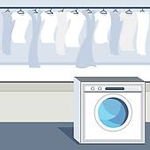 |  | 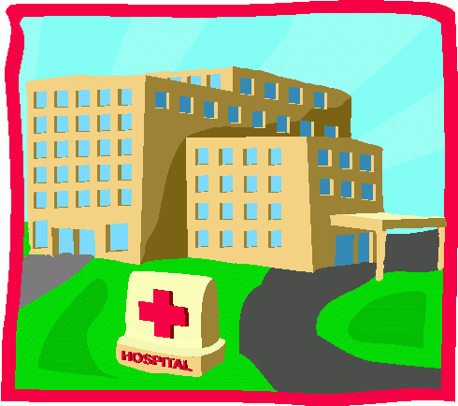 | 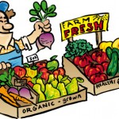
hairdresser’s | launderette | library | hospital | market
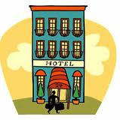 | 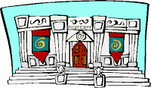 | 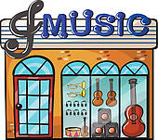 | 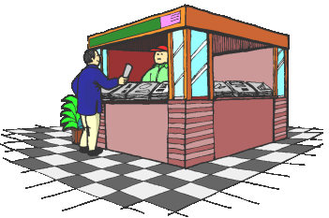 | 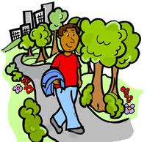
hotel | museum | music shop | newsagent’s | park
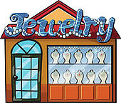 | 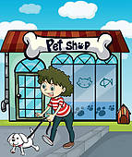 | 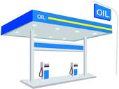 | 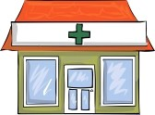 | 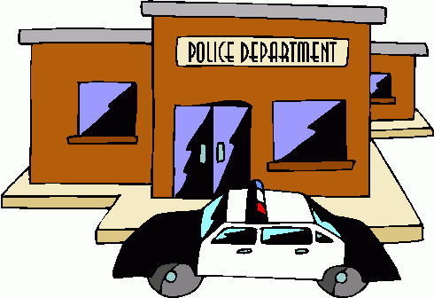
jeweller’s | pet shop | petrol station | chemist’s / pharmacy | police station
 | 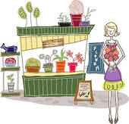 | 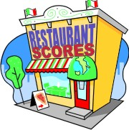 | 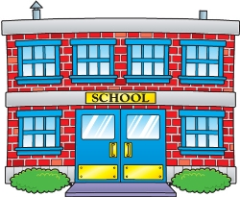 | 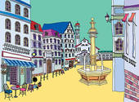
post office | florist’s | restaurant | school | square
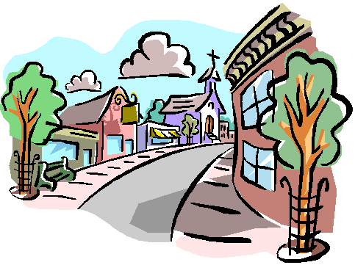 |  | 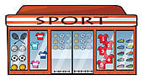 | 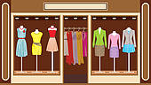
street | fishmonger’s | sports shop | clothes shop | shoe shop
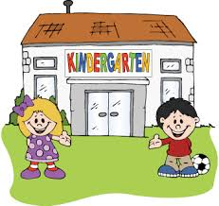 | 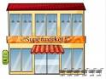 |  | 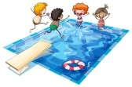
kindergarten | supermarket | sweet shop | swimming pool | theatre
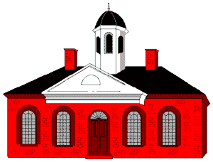 | 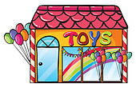 | 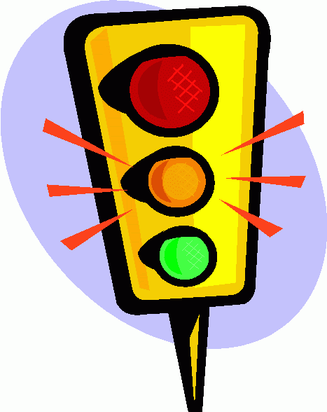 | 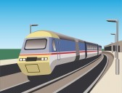
town hall | toyshop | Traffic lights | train/railway station | travel agent’s
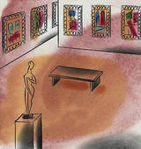 | 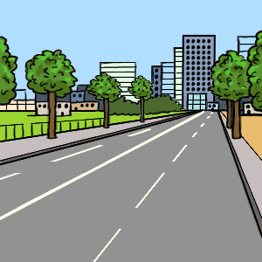 | 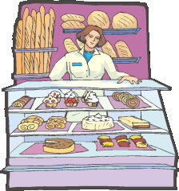 | 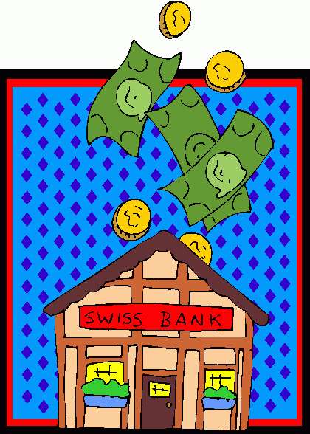 | 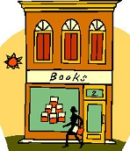
art gallery | road | bakery/baker’s | bank | bookshop
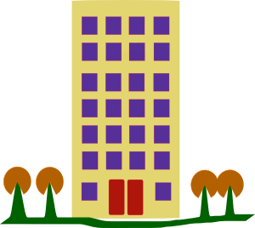 | 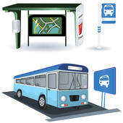 | 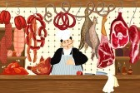 | 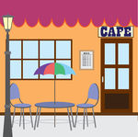 | 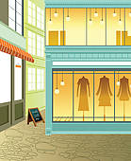
tower block | bus station | butcher’s | café / coffee shop | fashion boutique
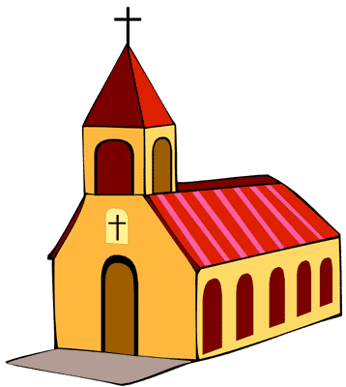 | 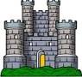 | 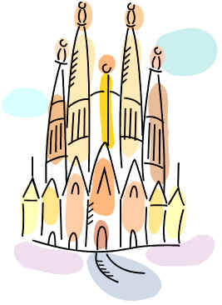 | 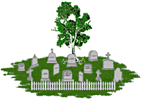 | 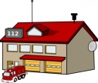
church | castle | cathedral | cemetery / graveyard | fire station
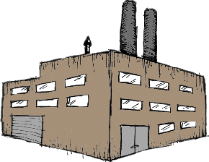 | 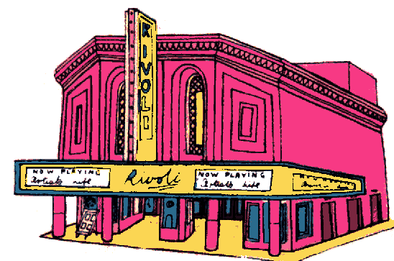 | 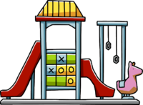 | 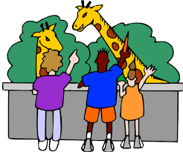
factory | cinema | playground | zoo | airport

To meet

Dopiši kar manjka: - besede za zgradbe. (Pomagaj si s slikovnim slovarjem.)
- kaj tam lahko delaš. (Glej že napisane stavke in uporabi sledeče glagole:
buy (4x) board (vkrcati se) catch (take) drink learn play pray see send visit watch
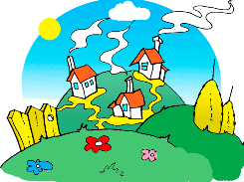 |  | 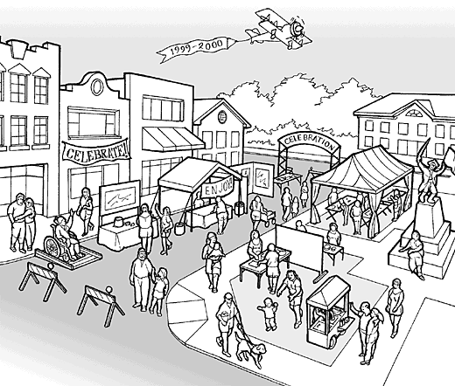 |  | 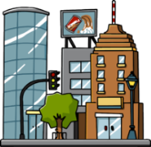
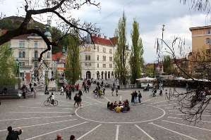 | A SQUARE |  | A square is an open space in the centre of the town.
 |  |  | YOU CAN drive your car on it.
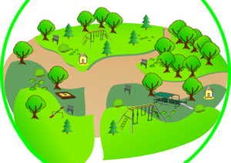 | A PARK |  | YOU CAN go there for a walk or for a picnic in nature.
 |  |  | YOU CAN…
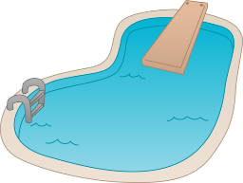 |  |  | YOU CAN swim there.
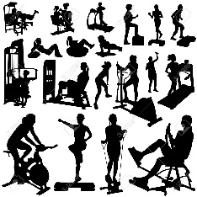 | A SPORTS CENTRE |  | A place where you can work out.
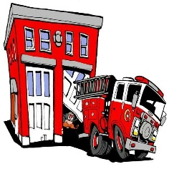 |  |  | A building where firefighters and fire trucks are.
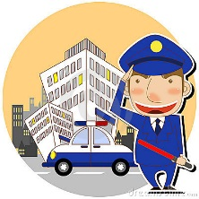 |  |  | A building where police officers work.
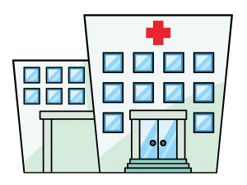 |  |  | YOU CAN…
 | AN EMERGENCY ROOM |  | You go there if you are hurt or if you have an accident.
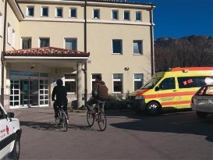 | A HEALTH CENTRE |  | You go there to see your doctor, dentist, etc.
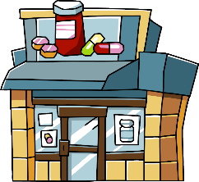 |  |  | YOU CAN…
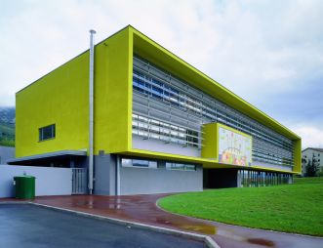 |  |  | YOU CAN…
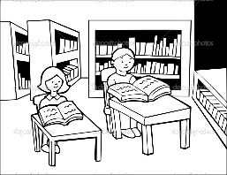 |  |  | You can read books and borrow them there.
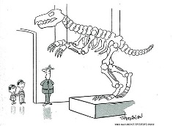 |  |  | You can see important and old objects there.
 | A GALLERY |  | YOU CAN…
 |  |  | You can see different plays there: comedies, tragedies, puppet plays …
 |  |  | YOU CAN…
 |  |  | You can save your money or ask for a loan there.
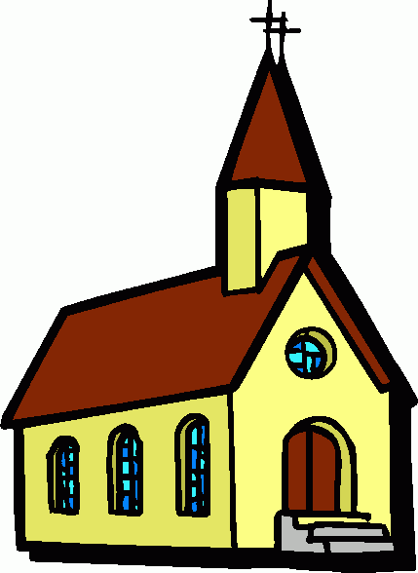 |  |  | YOU CAN…
 | A CLOTHES SHOP |  | YOU CAN…
Some other shops are: | A bookshop, a pet shop, a butchery, a gift shop …
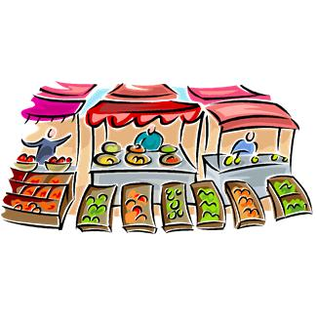 | A MARKET |  | You can buy fresh fruit and vegetables directly from the farmers.
 |  |  | YOU CAN…
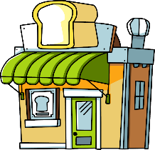 |  |  | You can buy fresh bread there.
 | A CAFÉ /  A COFFEE SHOP |  | YOU CAN…
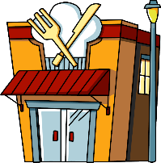 |  |  | A place where you can order a meal and eat.
 |  |  | You can stay there when you travel.
 |  |  | YOU CAN…
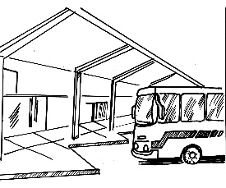 |  |  | YOU CAN…
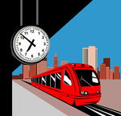 |  |  | You go there if you want to travel by train.
 |  |  | YOU CAN…
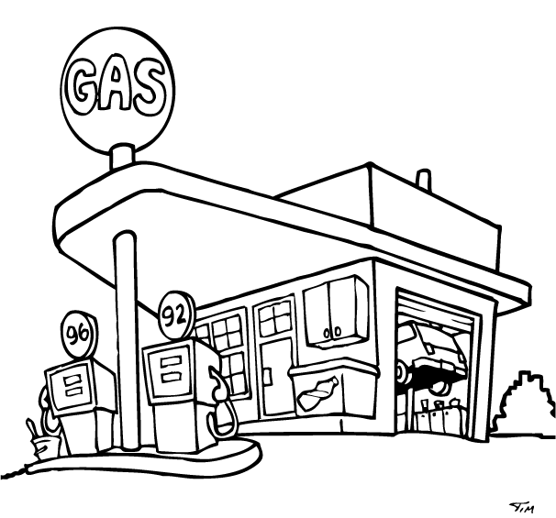 | A GAS STATION /  A PETROL STATION |  | YOU CAN…
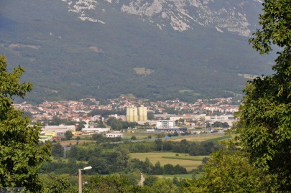
MY TOWN

Can you describe your town? Which places can you find in Ajdovščina? Answer the questions. (Odgovori na vprašanja.)
- Is there a hospital in Ajdovščina? _______________________________________
- Is there a police station in Ajdovščina? ___________________________________
- How many pharmacies are there in Ajdovščina? ________________________________
- Are there five swimming pools in Ajdovščina? __________________________________
5) What else is there in Ajdovščina? Name some buildings and places. Look at the examples. Write AT LEAST 8 sentences. (Napiši vsaj 8 povedi po spodnjem zgledu.)

There is a library so you can borrow books. (V Ajdovščini je knjižnica, torej si lahko izposodiš knjige.)
There are two swimming pools so you can….
………………………………………………………………………………………………………
………………………………………………………………………………………………………
………………………………………………………………………………………………………
………………………………………………………………………………………………………
………………………………………………………………………………………………………
………………………………………………………………………………………………………
………………………………………………………………………………………………………
………………………………………………………………………………………………………
………………………………………………………………………………………………………

