Pozdravljeni šestošolci!
Upam, da ste si oddahnili, izkoristili lepo vreme ta vikend in si nabrali energijo za ta teden preden boste lahko uživali v prvomajskih počitnicah.
Ta teden boste delali vaje za ponovitev in utrjevanje znanja. Poudarek bo na sedanjiku (trdilna, nikalna, vprašalna oblika glagolov, se spomnimo – do/does?)
Ponovili boste tudi prislove pogostosti (always, often, usually,…), se spomnili kje stojijo v stavku.
Poleg tega pa tudi prostore in pohištvo v hiši, zgradbe v mestu in kaj tam lahko delamo in predloge kraja (next to, in front of, above,…).

Svetujem vam, da se v tem tednu malo bolj posvetite angleščini. V petek boste na vaše email naslove dobili preverjanje znanja, ki ga boste takoj naredili in potem poslali nazaj meni.

Zdaj pa kar k nalogam! Nekaj nalog sledi na naslednjih straneh.
Nekaj nalog pa je na drugi povezavi. (Opazili ste dva linka na spletni strani.)

Pošljite mi str.4, 5 (naloge: C, D, E, F) do srede 22.4.!

Naloge pošiljaj in če imaš kakšne težave, piši na irena.scek@os-sturje.si

Negative

I don’t walk
You don’t walk
He doesn’t walk
She doesn’t walk
It doesn’t walk
We don’t walk
You don’t walk
They don’t walk
Interrogative

Do I walk?
Do you walk?
Does he walk?
Does she walk?
Does it walk?
Do we walk?
Do you walk?
Do they walk?

Affirmative

I walk
You walk
He walks
She walks
It walks
We walk
You walk
They walk

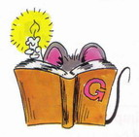

Short answers

Affirmative Negative

Yes, I / you / we / they do No, I / you / we / they don’t
Yes, he / she / it does No, he / she / it doesn’t
Third person singular

We add –s to the verb to form the third person singular (he, she, it).
I drink – he drinks
I run – he runs

BUT
- We add –es to verbs that end in –ss, -sh, -ch, -x, -o.
I watch – he watches

- With verbs ending in consonant + y, we change the –y to –ies.
I cry – he cries
But with verbs ending in vowel + y, we just add –s as usual.
I play – he plays

We use the Present Simple:

- for habits and actions that we do regularly:
He visits his friends every Sunday.
She goes to school by bus.

- for general truths:
The sun rises in the East.

- for permanent situations:
He lives in Athens.

A. Write the third person singular of the following verbs.
Dodaj spodnjim glagolom končnico s, es, ali še kaj spremeni, če je potrebno!

play ____________
go ____________
wash ____________
teach ____________
drive ____________
carry ____________
fly ____________
start____________
help ____________
kiss____________
watch ____________
tidy____________
like____________
enjoy____________
cry____________
mix____________

B. Complete the sentences with the Present Simple of the verbs in brackets.
Dopolni stavke s pravilno obliko glagolov v oklepajih! Pazi – s, ko je potrebno!

- Peter and his friends __________ to school by bus. (go)
- Elephants __________ leaves and grass. (eat)
- David's father __________ in a hospital. (work)
- The bank opens at 9.30 and __________ at 4.30. (close)
- Tom and Jim __________ football every day after school. (play)
- Mr Jones is a teacher. He __________ History. (teach)
- Our lessons __________ at 9.00 and __________ at 3.30. (start / finish)
- My pen friend __________ in Japan. (live)
- Mary and her brother __________ cartoons every Sunday morning. (watch)
- John __________ his room every day. (tidy)

C. Complete the blanks with the Present Simple of the verbs in the box.
Dopolni besedilo z ustreznimi glagoli v pravilni obliki. Dodaj s, ko je to potrebno!

deliver fish go jog love rest ride walk work
Mr Letty is a postman. He doesn't work in the post
office. He always works outside in the streets.
He __________ letters to all the people in the
neighbourhood every day. He doesn't __________
but he __________ his motorbike.
At the weekend, Mr Letty doesn't work.
He __________. He __________ the countryside,
so he always __________ to his country house with
his wife. Mr and Mrs Letty __________ in the river
and they __________ in the woods every weekend.

- Look at the pictures and write questions and answers, as in the example.
Glej slike in napiši vprašanja in odgovore, kot v primeru! Pazi – do ali does (na nekaterih slikah je več ljudi)!

- play / the guitar / in the afternoon
Does he play the guitar in the aftenoon?
No he doesn’t play the guitar in the afternoon.
He plays the accordion.
- walk / after lunch
_________________________________________
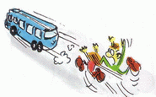
_________________________________________
- ride / their / bicycles / to work / every day
_________________________________________
_________________________________________
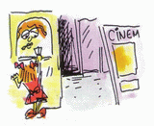
- listen / to the radio / every Sunday
_________________________________________
_________________________________________
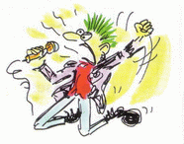
- clean / the house / on Mondays
_________________________________________
_________________________________________
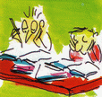
- watch / TV / after school
_________________________________________
_________________________________________
- Complete the blanks with the negative or the interrogative form of the Present Simple of the verbs in brackets.
Dopolni z glagoli iz oklepaja v pravilni obliki. Pazi – s; do, does- v vprašalnih in nikalnih stavkih!
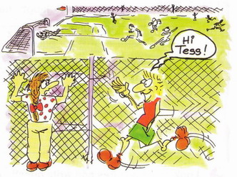
Mark: Hi, Tess! What are you doing?
Tess: I'm watching the football team.
Mark: Do you watch (watch) them every day?
Tess: No, I don't. They __________ (not play)
every day. They play four times a week.
Mark: __________ you __________ (have)
a favourite player?
Tess: No, I __________ (not have) a favourite player. Everyone on the team is
good.
Mark: __________ the attacker __________ (move) fast?
Tess: No, he __________ (not move) fast, but he's very clever. __________
you __________ (like) football, Mark?
Mark: No, I __________ (not like) it. I like basketball. It's a great sport.

F. Make questions for the undelined words.
Napiši vprašanja tako, da bo odgovor podčrtana beseda v stavku. Pazi, za vprašalnico mora vedno biti do ali does (he/ she/ it)!

1 Peter gets up at five o’clock. _____________________________________
2 Jack and Jean go to bed early.____________________________________
3 Jane cooks dinner in the evening._________________________________
4 Tom goes to work by bus._________________________________________
5 Andres and Ana work in an office._______________________________________
6 Maria has breakfast at eight o’clock._____________________________________
7 They like Geography because their teacher is very nice. _______________________________________________

12
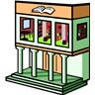
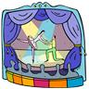
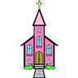
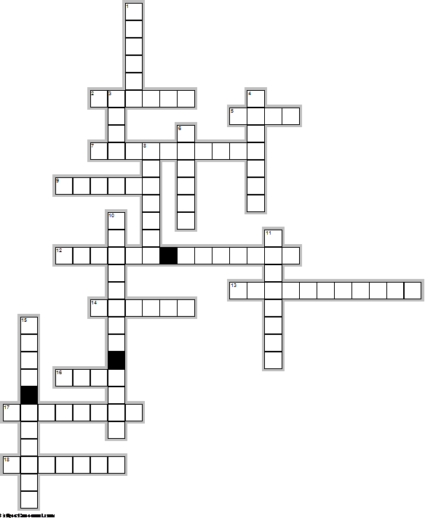
16
14
18
11

15
13
17
8
2
1
6
5
9
EclipseCrossword.com
4
10

7
3
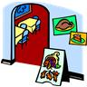

CHOOSE THE RIGHT OPTION Izberi ustrezno izmed krepko tiskanih besed!
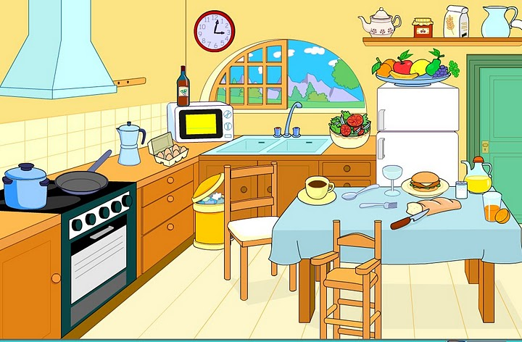
1-THE FRIDGE IS BETWEEN/UNDER THE DOOR AND THE CUPBOARD.
2-THE DOOR IS NEXT TO/UNDER THE SHELF.
3-THE CLOCK IS IN/ON THE WALL.
4-THE CHAIRS ARE UNDER/ NEXT TO THE TABLE
5-THE TABLE IS UNDER/OPPOSITE THE COOKER.
6-THE POT IS ON/IN THE COOKER.
7-THE BIN IS NEAR/ IN FRONT OF THE DRAWERS.
8-THE MICROWAVE IS NEXT TO /UNDER THE WINDOW
9-THE SINK IS ABOVE/UNDER THE WINDOW.

COMPLETE WITH THE RIGHT PREPOSITION Dopolni z ustreznim predlogom (between, under,…)
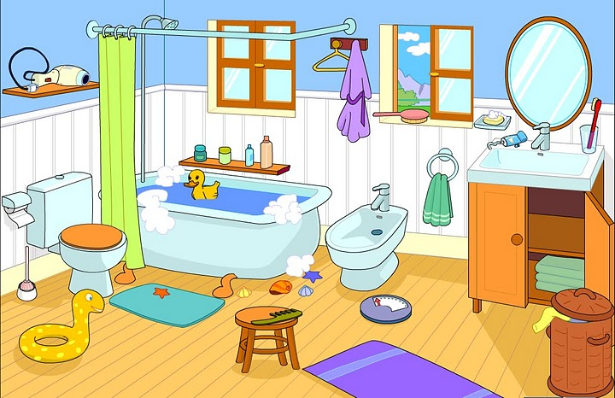
1-THE TOILET IS ………………..THE BATH
2-THE CURTAIN IS………………….THE TOILET AND THE BATH.
3-THE SHELF IS …………….THE WALL
4-THE MIRROR IS …………….THE WASHBASIN
5-THE CUPBOARD IS …………………..THE WASHBASIN
6-THA MAT IS ………………..THE TOILET
7-THE STOOL IS ……………….THE BATH.
8-THE BIN IS ………………..THE CUPBOARD.
9-THE TOWELS ARE ……………..THE CUPBOARD.

