
often
never
always
usually
not often
normally
sometimes

We put adverbs of frequency:
before the main verb
We sometimes go to the cinema on Sunday.
after the verb to be
He is often late.
between the auxiliary verb and the main verb
I don’t often drink coffee.

Primer: They don’t work at weekends. (usually)
They don’t usually work at weekends.
He teaches English in the morning. (always) ............................................................................................
She is late for school. (never)
............................................................................................I don’t eat eggs for breakfast. (usually)
............................................................................................We go out on Sunday evening. (often)
............................................................................................I get up early. (sometimes)
............................................................................................He doesn’t read books in the evening. (often) ............................................................................................
............................................................................................
Put the words in the correct order.
Postavi besede v pravilno zaporedje
Primer: Mary/eats/never/fish
Mary never eats fish.
is/brilliant/he/always/on/keyboards
............................................................................................
don’t/you/sit/here/usually
............................................................................................
parents/my/the theatre/don’t/go/to/ often ............................................................................................
............................................................................................
am/for/meals/late/I/never
............................................................................................
we/on time/are/never
............................................................................................
a shower/we/after/have/training/ usually ............................................................................................
I/bad/never/dreams/have
............................................................................................
very/their/music/sometimes/is/good
............................................................................................
play/they/sometimes/basketball/ school/after
............................................................................................
doesn’t/early/often/she/get up
............................................................................................
our/are/ Saturday/usually/matches/on/ morning ............................................................................................
............................................................................................
sugar/they/in coffee/always/have
............................................................................................
drink/they/usually/for breakfast/tea/ don’t
................................................................................
you’re/for/late/always/class
…………...........................................................................................
Correct the sentences.
Popravi stavke. Označi, kje bi morala biti napačno postavljena beseda.

She has sometimes coffee with milk.
............................................................................................
They go usually abroad for holidays.
............................................................................................
Sue doesn’t never forgets my birthday.
............................................................................................
David always is hungry.
............................................................................................
I don’t play often computer games.
............................................................................................
Jill doesn’t eat often meat.
………………………………………………………………………………………..
............................................................................................
Linda gets always up at six o’clock.
............................................................................................

Correct the sentences:
Add the adverb of frequency in the right place:
Postavi besedo v oklepaju na pravo mesto v stavku!
Adapted from Kamila: http://www.eslprintables.com/printable.asp?id=182506#thetop
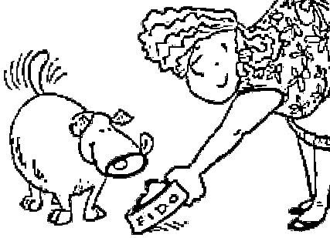
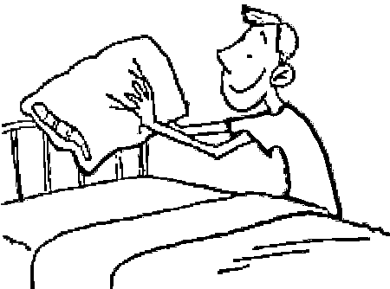
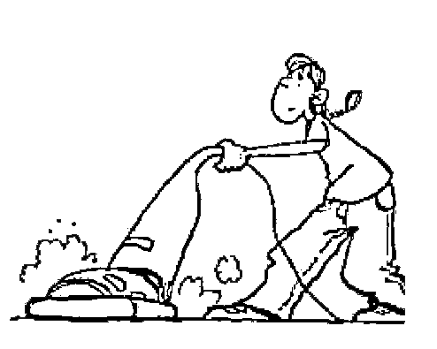

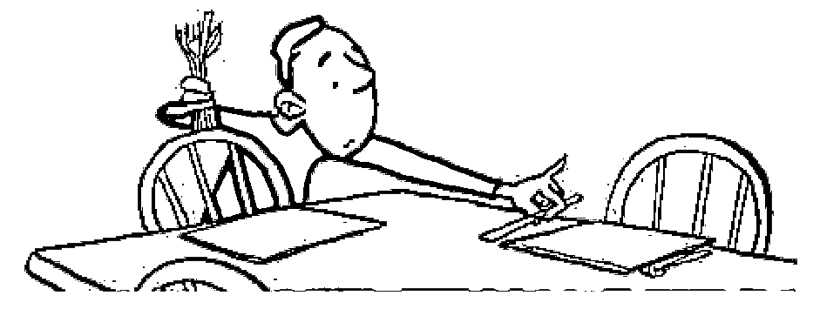
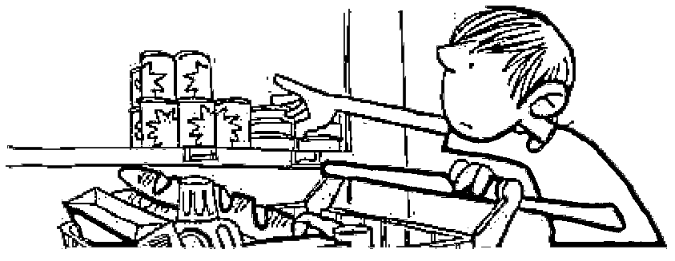
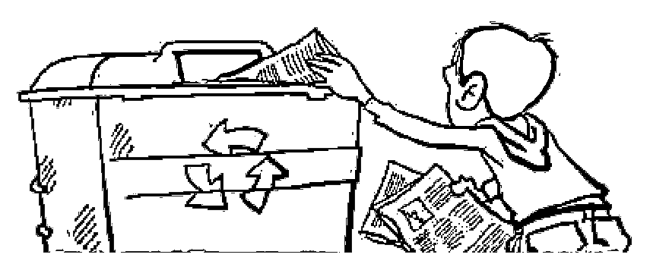
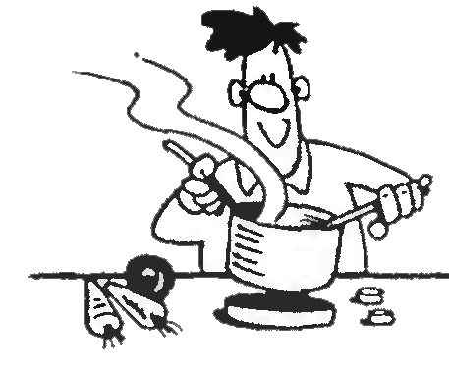
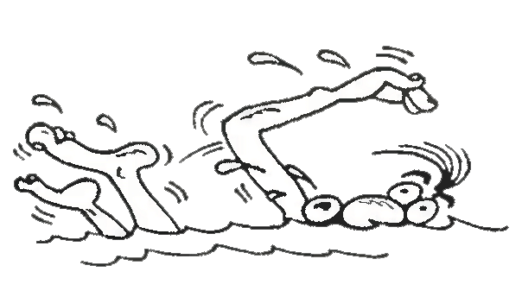
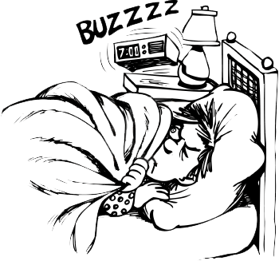
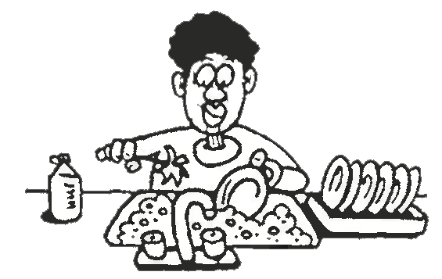
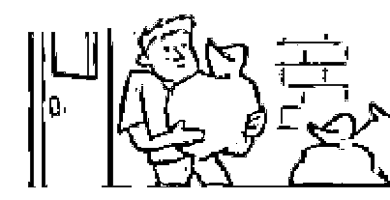
MATCH AND WRITE.
Izberi besede, ki spadajo k slikam in zapiši stavke!

make his bed
go swimming
wash up
do the shopping
get up early
cook
a dinner
vacuum the floor
set the table
feed the dog
take out the rubbish
take newspa-pers to the recycling centre
clean the car

______________________________________________________

my mum / not often

______________________________________________________

my mother / always

______________________________________________________

______________________________________________________

my brother / sometimes

______________________________________________________

I / never

______________________________________________________

My father / often

______________________________________________________

he / usually

______________________________________________________

my uncle / always
1
2
3
4
5
6
7

______________________________________________________

Nick / sometimes
8

______________________________________________________

______________________________________________________________________

his father/ usually

______________________________________________________________________

I / never
9
10
11
12
my sister / normally
Our neighbour/ not often

