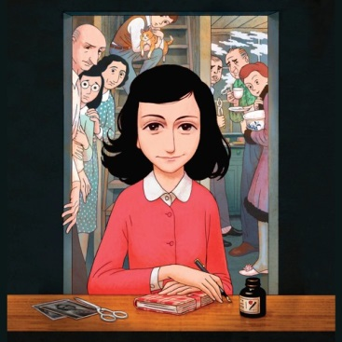
Anne Frank and her diary
- Pred branjem v slovarju poišči in prevedi naslednje besede oz. besedne zveze:
(na spletu uporabi slovar PONS in ne google prevajalnik!!!!)
to go into hiding –
to be in power –
to force –
to commit a crime –
to experience –
to occur –
to revise –
to pass away –
fulfill one’s wish –
horrific –
caring – confident –
frightful –
fate –
source –

- Preberi spodnje besedilo o Anne Frank.
Anne Frank is a famous author. She was born on June 12 to a Jewish family. Anne lived during one of history’s most horrific times. She lived in Germany and Amsterdam when Hitler was in power. Anne and her family were forced to go into hiding because they feared the Nazis and what they were doing to Jewish families. Sadly, they were found, arrested and sent to concentration camps. They became prisoners, not because they had committed any crime, but simply for whom they were. Regardless the horrors around her, Anne Frank remained a kind-hearted and caring young lady.
While in hiding Anne kept her secret diary in which she shared her fears, hopes and experiences. She also wrote about the other people living in hiding with her family. She wrote about the sad fate that so many other Jewish people were experiencing. The more she wrote, the more confident she became. After the family was arrested, the diary was kept by one of the Frank family’s friend.
After writing in her diary for nearly two years, Anne heard a radio broadcast where the government official asked citizens to keep journals and letters during the war. He thought that all written sources could be published after the war so no one could forget what had occurred during that frightful time. Anne took his message very personally: she revised her thoughts and rewrote some of them in hope that her diary could be published one day.
Unfortunately, Anne passed away due to illness and severe conditions in the camp in March 1945. Only her father, Otto, survived the war and fulfilled Anne’s wish. After his daughter’s writings were returned to him, Otto managed to publish the diary. Today it’s been translated into many languages and remains one of the most famous books in the world.
3. Odgovori na vprašnja. Odgovore zapiši v povedih! :
1. Who is Anne Frank?
_____________________________________________________________________________________________________________________________________________________________________________________________
2. Why Anne’s family was forced to go into hiding?
_____________________________________________________________________________________________________________________________________________________________________________________________
3. Where Anne and family were sent after the arrest?
_____________________________________________________________________________________________________________________________________________________________________________________________

4. What did she write about in her diary?
_____________________________________________________________________________________________________________________________________________________________________________________________
5. Why did the government official tell people to keep journals and letters?
_____________________________________________________________________________________________________________________________________________________________________________________________
6. Did Anne publish her diary? When was it published?
_____________________________________________________________________________________________________________________________________________________________________________________________
7. Do you keep a diary? Why/Why not?
_______________________________________________________________________________________________________________________________ _______________________________________________________________
8. Do you know the book Anne Frank’s diary?
_____________________________________________________________________________________________________________________________________________________________________________________________
I think she can be a great inspiration for us all today. She stayed in hiding for 761 days. Today some people have problems staying in their homes after 14 days. What do you think about Anne Frank? Can she be an example for you? Can her story help you stay inside in the following days, weeks? How is staying at home different for you as it was for Anne? Why is it much easier?
Explain your thoughts in about 12 sentences!

______________________________________________________________________________________________________________________________________________________________________________________________________________________________________________________________________________________________________________________________________________________________________________________________________________________________________________________________________________________________________________________________________________________________________________________________________________________________________________________
______________________________________________________________________________________________________________________________________________________________________________________________________________________________________________________________________________________________________________________________________________________________________________________________________________________________________________________________________________________________________________________________________________________________________________________________________________________________________________________

