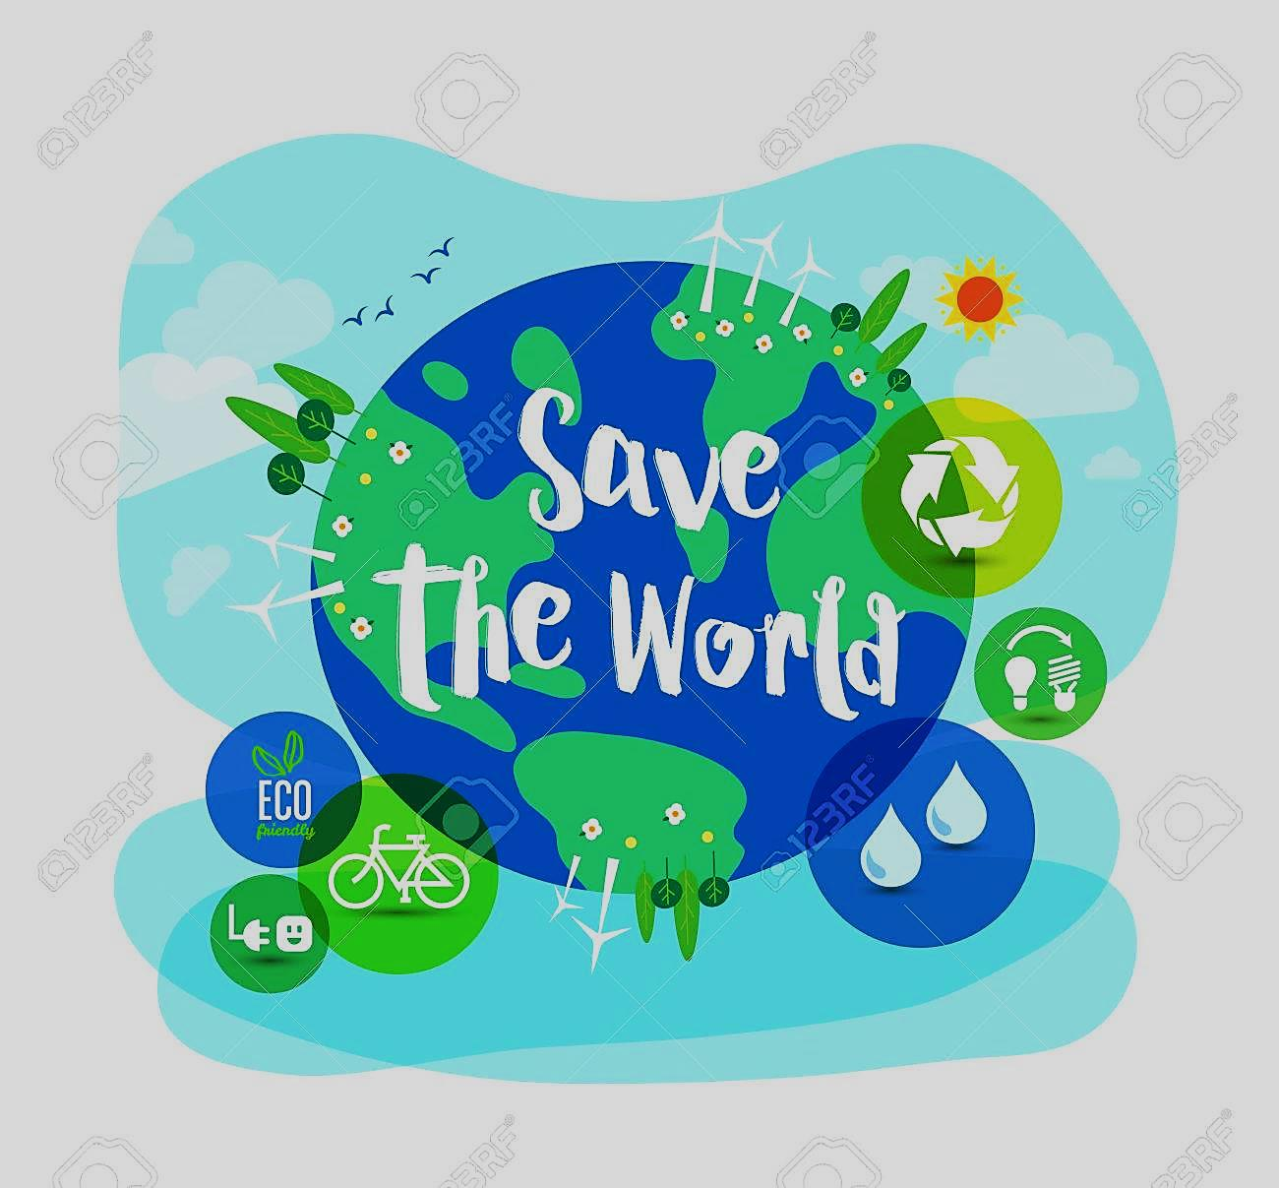
READING.
Our planet is very generous to us! It gives us water,it gives us oxygen,it gives us everything to survive! But…What do you do to protect our planet? There are many ways! Let’s make a short list of the things we can do:
- Plant trees . Trees are very important for a healthy life on planet.So we can plant many trees. Also it is very important to be careful when we go to a forest .Forest fires are the worst things for our planet.

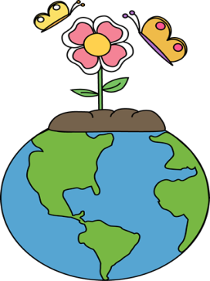
- Try to use less water when you brush your teeth. Don’t leave the water running while brushing your teeth.

- Take quick showers.

- Use bikes instead of cars or you can walk. Cars pollute the air.

- Reuse everything.Don’t throw things away after using them just once.Use them multiple times.

- Send the used paper to recycling. If the old paper is recyled, people will cut less trees. Put the old paper in the recyle bin.Put the glass in the glass bin.

- Turn off the lights when you don’t need them. Save energy!

If we want to go green and become environmentally friendly, we must do these things. Because we need trees, we need water and we need oxygen!

Part A. Read the text and write true or false.
(Preberi besedilo in zapiši, ali so trditve pravilne –T, ali napačne –F.)

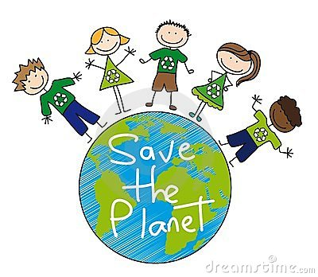
- Forest fires are bad for our planet . _________.
- There isn’t anything to do to save the World .________.
- Cars are not harmful for environment. _________.
- Recycling is very important to save energy. _______.
- Environmentally friendly people use bikes not cars. ________.

VOCABULARY
PART A. Put a tick if the word has a positive meaning and put a
if it has a negative meaning.
(Zapiši k besedam, ki pomenijo nekaj dobrega, X pa k tistim, ki pomenijo nekaj slabega.)
waste pollute
save reuse
throw away go green
recycle environmentally friendly

Part B. Use the words in Part A to complete the sentences.
(Dopolni povedi z besedami iz naloge A.)
1.Don’t ______________ water. Have quick showers.
2. Turn old things into new things, ______________ paper,glass or plastic bottles.
3. You can do many things to be __________________________.
4. When something is broken don’t ____________________,try to fix or reuse it.
5. Walk to school or use public transport because cars ___________the air.
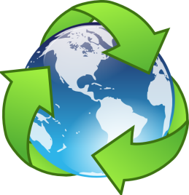
Part C. Write the things we can do to protect our world under each picture. (Izbiraj med danimi besedami in jiz zapiši pod ustrezne slike.)
Recycle Use bikes Reuse Turn off the lights
Plant trees Use less water in the shower
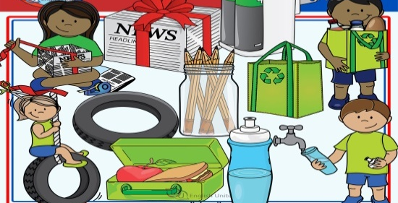
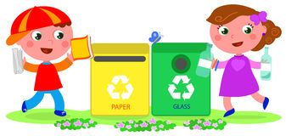
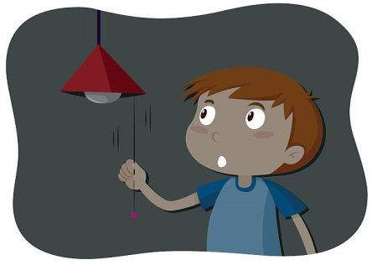

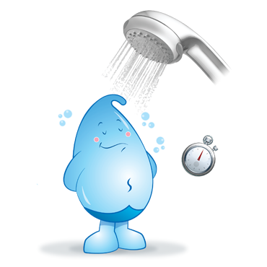
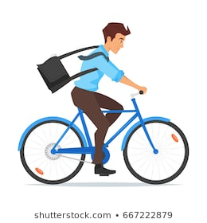
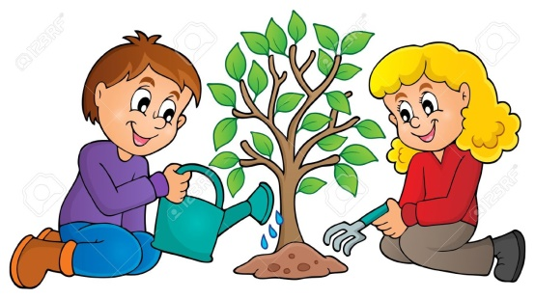

USE OF ENGLISH
Part A. Match the phrases.
(Smiselno poveži dele povedi. Zapiši črke k ustreznim številkam v okvirju.)
- Use bikes instead of cars a. save water
- Don’t throw away things, try to b.paper, plastic bottle and glass.
- We can recycle c.22nd April.
- There are many ways d.because cars pollute the air
- People celebrate Earth day on e.reuse them again and again.
- Take short showers to f.to protect the planet
- _____ 2. _____ 3. _____ 4. _____ 5._____ 6. _____
Part B. Order the sentences. (Uredi besede v pravilno zaporedje in zapiši povedi.)
- is / on / 22nd April /Earth day.
______________________________________________________________.

- recycle / can / paper and / you / glass.
______________________________________________________________.

- save / water / short / showers.
______________________________________________________________.

- People/ trees / on / earth day / plant.
______________________________________________________________.

- your computer / when /turn off / you aren’t / it / using.
______________________________________________________________.

Part C. Circle the correct answer. (Obkroži ustrezne besede.)
- Go / Going green is not difficult if you be environmentally friendly.
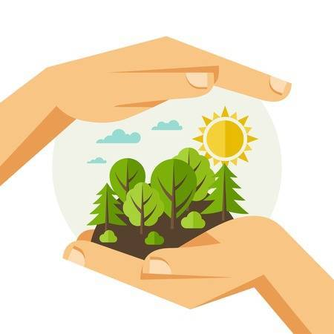
- Don’t / Not use cars try to use public transport.
- Never / Always use things again and again.
- Use more /less water in the shower.
- Turn on / off the lights when you don’t need them.
WRITING.
Write the things to do or not to do to protect the environment.You can add your own ideas.
(Zapiši kaj moramo, oziroma ne smemo delati, da bi zaščitili okolje.)

DON’T do it
- _____________________
- _________________
- _________________
- _________________
- __________________
DO it
- _____________________
- _________________
- _________________
- _________________
- __________________

