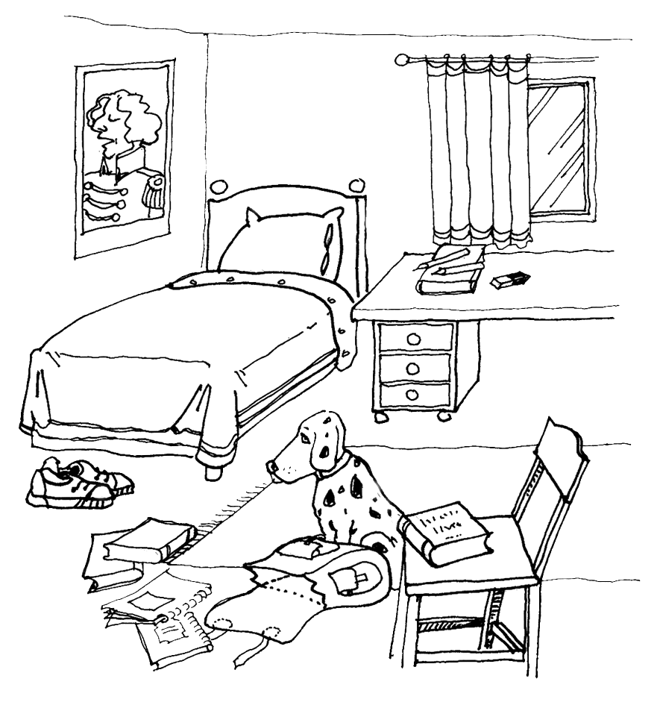

Look at the picture and tick true (T) or false (F).
Correct the false sentences. (Popravi napačne stavke.)
T F
1. The shoes are under the bed. 
2. A book is on the chair.
3. The dog is next to the schoolbag.
4. The curtains are behind the window.
5. The bed is behind the desk.
6. The pencils are between the book and drawer.

Look at the pictures are write a or b in the sentences.
(Glej sliki in zapiši a ali b k ustreznim stavkom.)
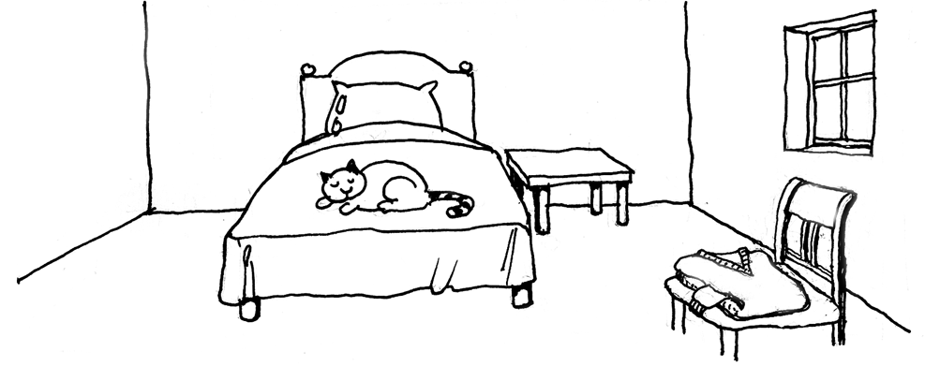
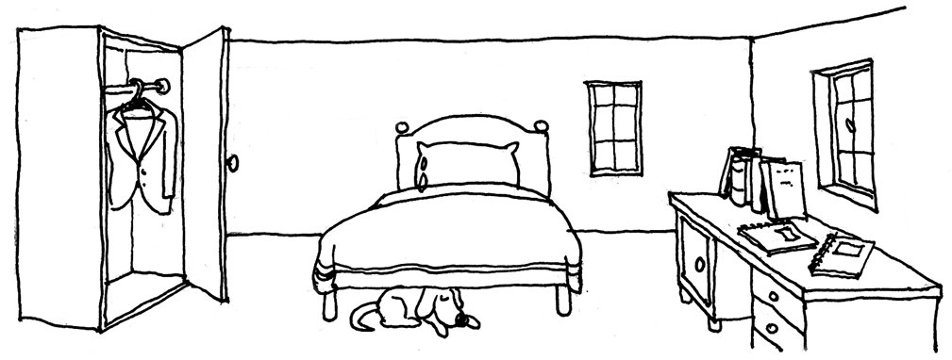

___ 1. The room has got two windows.  a  b  ___ 2. There is a cat on the bed.  ___ 3. There is a table near the bed.  ___ 4. A dog is under the bed. | ___ 5. Some books and notebooks are on the desk.  ___ 6. The chair is under the window.  ___ 7. A jumper is on the chair.  ___ 8. There is a jacket in the cupboard.

There are five children from different countries in a summer camp. They are in
different rooms. Read the sentences and complete the chart.
(Pet otrok iz različnih držav je na poletnem taboru. Vsak je v svoji sobi. Preberi opise in dopolni tabelo.)
5
Name  Room 1  Room 2  Room 3  Room 4  Room 5 |  |  | Harry |  |  | Teacher’s
City |  |  |  |  |  | Room
1. Harry is in room 3.
2. Pierre is next to the teacher’s room.
3. John is in the room between Harry and Roberto.
4. Edu is in the room next to Pierre.
5. The boy next to Roberto is from London.
6. Harry is from Amsterdam. He is between the boys from London and from Seville.
7. The boy in the room next to Edu is from Paris.
8. The boy from Rome is next to the boy from London.
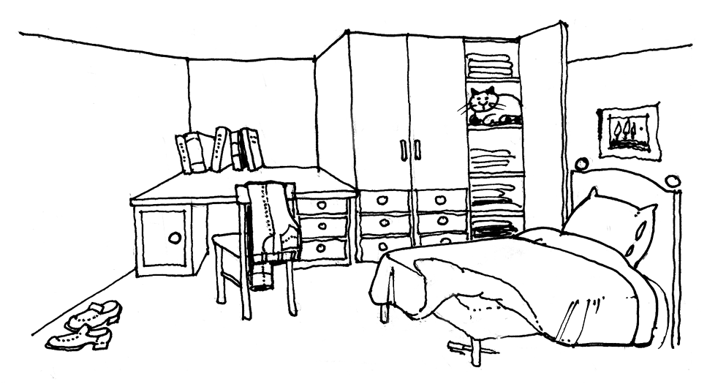
Write a description of the room.
(Opiši sobo na sliki. Napiši tudi, kje se nahaja pohištvo.)

_________________________________________
_________________________________________
_________________________________________
_________________________________________

