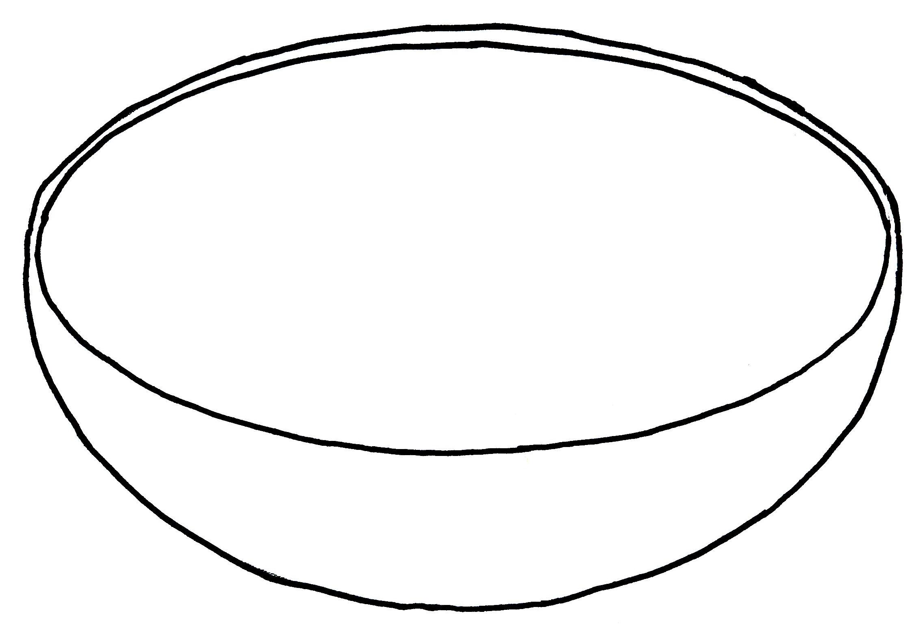

**COUNT AND COLOUR.**

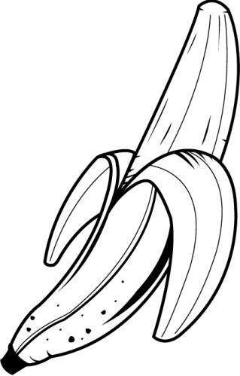

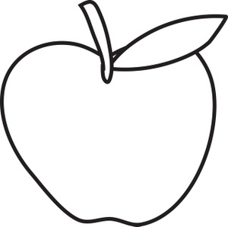

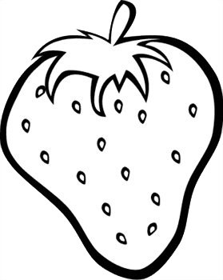

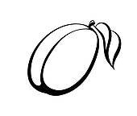

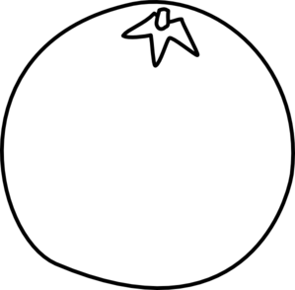

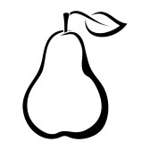











































|  |  |  |  |  |  |
| --- | --- | --- | --- | --- | --- |
|  |  |  |  |  |  |
|  |  |  |  |  |  |
|  |  |  |  |  |  |
|  |  |  |  |  |  |
|  |  |  |  |  |  |
|  |  |  |  |  |  |
| http://clipartion.com/wp-content/uploads/2015/10/school-apple-clip-art-free-clipart-images.jpg | http://images.clipartpanda.com/pear-clipart-black-and-white-28461439-pear-black-contour.jpg | http://sr.photos3.fotosearch.com/bthumb/CSP/CSP994/k16165191.jpg | http://www.clipartbest.com/cliparts/yio/4Ao/yio4Ao5RT.jpeg | http://www.webweaver.nu/clipart/img/misc/food/fruit/strawberry-line-art.jpg | Orange Clip Art |