You can watch the movie here: https://www.youtube.com/watch?v=EO8fVISYN64
Odgovore zapiši na list in shrani v mapo!

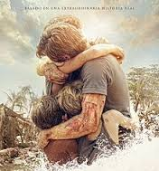
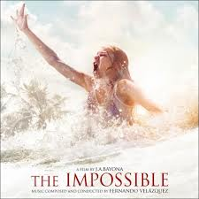
THE IMPOSSIBLE

Part 1
- Where was the family when the movie started?
- Where were they going on vacation?
- Describe the summer resort where they were.
- What were they celebrating on the beach at night? How did they do it?
- What did they do the next morning?
- Did they surf, dive o swim?
- What were they doing before the Tsunami hit the beach?
- Where did Maria and Lucas hold?

Part 2
- Who did they find and help?
- Where did they refuge from the Tsunami?
- Who helped Maria and Lucas?

Part 3
- Where and how did the bothers find each other?
- Who helped the Bennett family return home?
- Where did they travel by plane?

Part 4

What do you think people should do in a case of a tsunami? Did they do that in the movie? What would you do if you were in their place?

