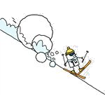
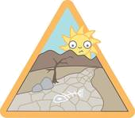
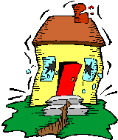
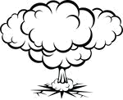

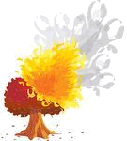
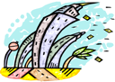
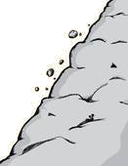
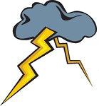
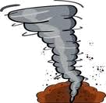
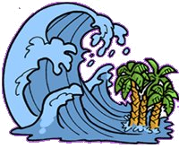
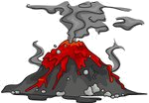
NATURAL DISASTERS
Match the names of the disasters to the pictures. Then read the information about some of them and write their names on the line.
1 lightning 2 volcanic eruption 3 flood
4 avalanche 5 hurricane 6 drought
7 explosion 8 landslide 9 tornado
10 earthquake 11 forest fire 12 tsunami

A mass of snow, ice and rock that slides rapidly down the side of a mountain: _____________________________
Coming of a great quantity of water over a place: _____________________________
Lava, cinders, gases come up suddenly from below the earth surface through an opening of a mountain: _____________________________
A series of water waves caused by the displacement of a large volume of body water : _______________________
Violent and destructive storm over a small area: _____________________________
An uncontrolled fire in an area of combustible vegetation that occurs in the countryside or a wilderness area: _____________________________
Sudden violent movement of the earth’s surface: _____________________________
Continuous dry weather, when there is not enough water for people’s needs: _____________________________

