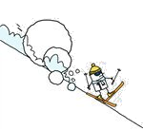
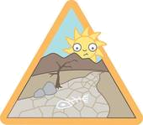
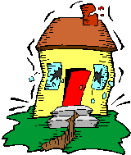
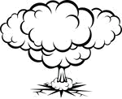

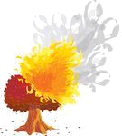
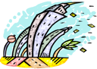
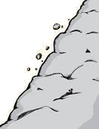
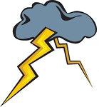
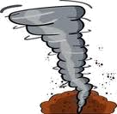
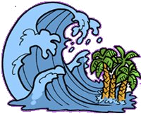
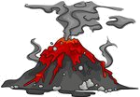
NATURAL DISASTERS
Match the names of the disasters to the pictures. Then read the information about some of them and write their names on the line.
1 lightning 2 volcanic eruption 3 flood
4 avalanche 5 hurricane 6 drought
7 explosion 8 landslide 9 tornado
10 earthquake 11 forest fire 12 tsunami

A mass of snow, ice and rock that slides rapidly down the side of a mountain: ______AVALANCHE_______________
Coming of a great quantity of water over a place: ______FLOOD______________
Lava, cinders, gases come up suddenly from below the earth surface through an opening of a mountain: ______VOLCANIC _ERUPTION________
A series of water waves caused by the displacement of a large volume of body water : _______TSUNAMI________________
Violent and destructive storm over a small area: _________HURRICANE____________
An uncontrolled fire in an area of combustible vegetation that occurs in the countryside or a wilderness area: _____FOREST FIRE______
Sudden violent movement of the earth’s surface: __________EARTHQUAKE_____________
Continuous dry weather, when there is not enough water for people’s needs: _____________DROUGHT_______________
4
6
10
7
3
6
9
8
1
9
12
2

