
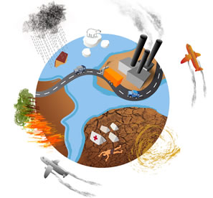

April 22 is Earth Day. Every year, million of people from 200 countries celebrate Earth Day to teach people to protect the planet and its natural resources.
Here’s what you can do to help.

ORIGIN
The idea for the first Earth Day came from Senator Gaylord Nelson, an American politician. In 1970, pollution in the USA was very bad : about
60% of lakes and rivers were polluted.
Senator Nelson told Americans to protest and over 20 million people joined demonstrations around the country.

In 1990, 20 years after the first Earth Day, environmental leaders from other countries asked to join the movement. That year, 200 million people from 141 countries celebrated Earth Day.
In 2000, 500 million people from 184 countries participated.

YOU CAN HELP THE PLANET
The planet has many problems, like air pollution, deforestation and water pollution.
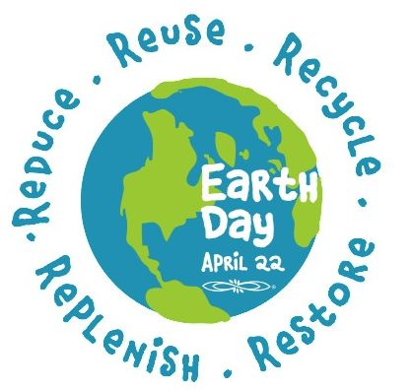
GO GREEN!
GOING GREEN means thinking and caring about the environment.
The three R’s of going green are : REUSE, RECYCLE, REDUCE.

+ REUSE We should repair things instead of throwing them away.

+ RECYCLE In the UK, people throw away seven billion drink cans a year.

+ REDUCE Carbon dioxide ( CO2 ) is essential for the photosynthesis of plants, therefore for life on Earth. Its origin is mainly natural, but deforestation, intensive use of petrol and coal, and cars produce huge quantities of this gas, which contributes to the greenhouse effect.
We have to learn how to reduce our consumption of energy.

THINGS YOU AND YOUR FAMILY CAN DO TO HELP THE PLANET
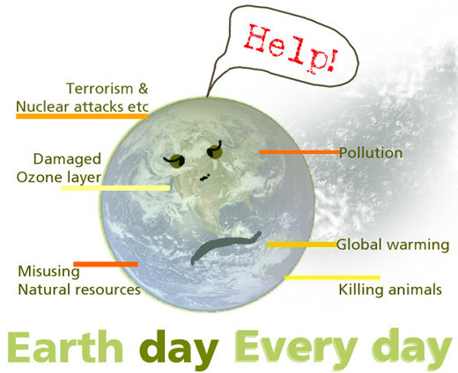
-Take short showers to save water.
-Turn off the lights when you leave the room.
-Don’t leave the fridge door open for too long.
-Don’t leave water running when you brush your teeth.
-Turn of TVs and stereos, don’t leave them on standby.
-Don’t put batteries in the rubbish bin. And use rechargeable batteries.
-Sell or give away clothes and objects you don’t use.
-Use eco-friendly products.
-Walk or ride a bicycle or use public transport. Cars create air and noise pollution and traffic. Pollution from cars and power stations cause acid rain which can harm trees and damage buildings and can kill fish.
-Always pick up your rubbish.
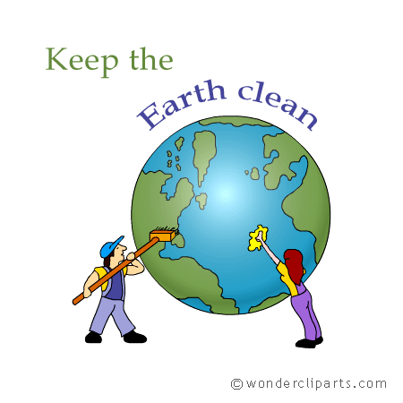
-Plant a tree, trees protect the soil from erosion and purify the air by converting carbon dioxide into oxygen. They also provide food and shelter for other fauna and flora.
-Use recyclable paper and don’t waste paper and paper products.
-Use shopping bags, not plastic bags. Every minute, one million plastic bags are used around the world : that’s 500 billion plastic bags a year. The bags last 20 to 1,000 years, because they are not biodegradable. Thousands of marine animals die every year because they accidentally eat old plastic bags.
-Insulate buildings to stop wasting energy.

UNDERLINE WHAT IS WRONG AND CORRECT IT!

1) Earth Day is only celebrated every two year..................................................................................................................................................
2) 43% of lakes and rivers in the USA were polluted in 1970...................................................................................................................
3) The Americans are the only ones to celebrate Earth Day.....................................................................................................................

CIRCLE THE CORRECT ANSWER

1) The first Earth Day took place in ..................... a) 1970 b) 1990 c) 1997

2) ................................... of American lakes and rivers were polluted. a) 43% b) 60 % c) 0%

3) The first Earth Day took place ........................... a) in France b) all over the world c) in the USA

4) Earth Day makes you remember that you ............................ your environment
a) mustn’t protect b) must protect c) can’t protect

5) Today there are..... a) no more environmental problems b) more environmental problems
c) still some environmental problems

6) Earth Day became international in a) 1970 b) 1990 c) 1997

7) ....................... are acceptable on Earth Day. a) only individual actions b) only collective actions
c) both collective and individual actions

FIND THE WORDS the remaining letters will tell you to do something really nice to help the planet!
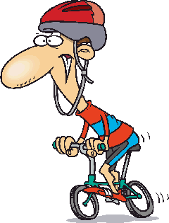
ACTIVIST FORESTRY
ALUMINIUM GAS
ATMOSPHERE NUCLEAR
BEACH OCEAN
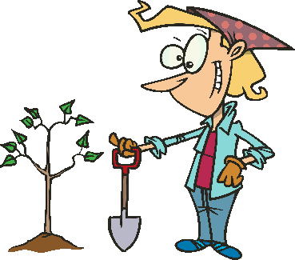BICYCLE OZONE
BOTTLES PLANTING
BUS PLASTIC
CHEMICALS POLLUTION
COAL PROTEST
CORAL REEF PURIFY
DEMONSTRATION RECYCLE
EARTH DAY SEA
ELECTRICITY SOLAR POWER
ENDANGERED STREAM
EXTINCT SUMMIT
WIND FARM

P | S | T | M | R | B | O | B | M | L | E | T | N | B | R
A | L | S | F | U | E | I | A | E | N | A | O | R | O | A
T | A | I | O | C | I | E | C | D | A | I | O | E | T | E
M | C | V | R | Z | R | N | A | Y | T | C | N | C | T | L
O | I | I | E | T | O | N | I | A | C | A | H | Y | L | C
S | M | T | S | T | G | N | R | M | E | L | O | C | E | U
P | E | C | T | E | A | T | E | C | U | S | E | L | S | N
H | H | A | R | U | S | C | O | R | A | L | R | E | E | F
E | C | E | Y | N | R | E | W | O | P | R | A | L | O | S
R | D | B | O | E | L | E | C | T | R | I | C | I | T | Y
E | U | M | R | N | O | I | T | U | L | L | O | P | P | L
S | E | A | R | T | H | D | A | Y | F | I | R | U | P | A
D | G | N | I | T | N | A | L | P | L | A | S | T | I | 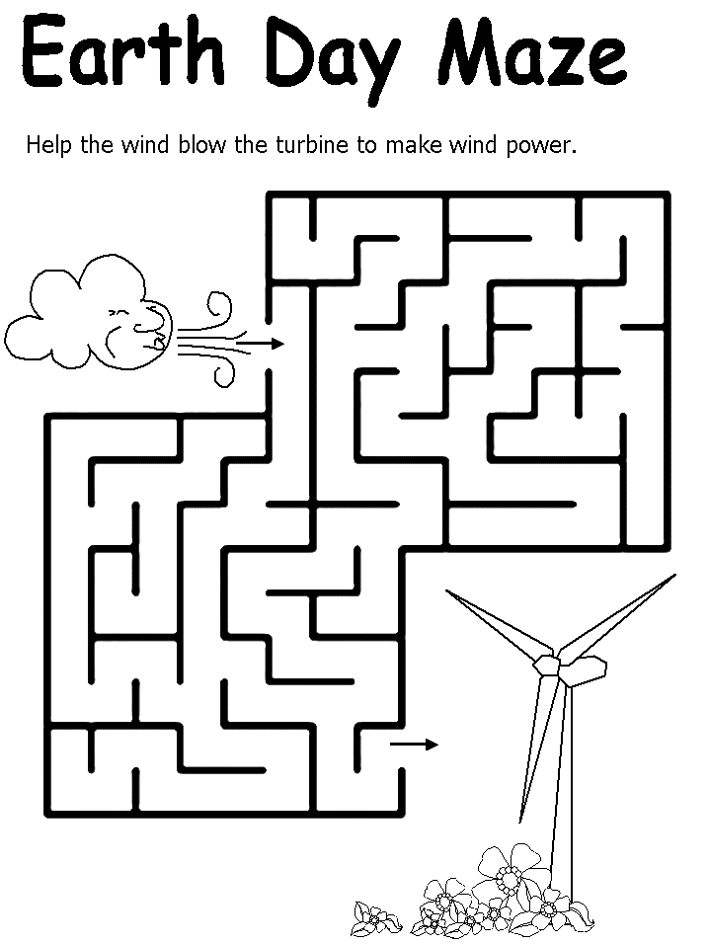  C
S | U | M | M | I | T | W | I | N | D | F | A | R | M | N
P | R | O | T | E | S | T | C | N | I | T | X | E | E | T
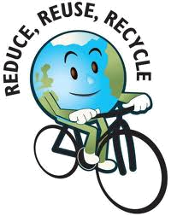

“Make everyday Earth Day
by doing your share
Make everyday Earth Day
if you really care
Every little bit matters
for the earth, air and sea
Every little bit matters
for world ecology”



