**http://images.clipart.com/thm/thm5/CL/STGR003/broder1-1a/alp29/alp34001.thm.jpg**

images.jpg

**READING COMPREHENSION**

**Read the text carefully.**

The Griffins are a family of fictional characters from the [animated television](http://en.wikipedia.org/wiki/List_of_animated_television_series) series “[Family Guy](http://en.wikipedia.org/wiki/Family_Guy)”. Peter and Lois Griffin have three children: Meg, Chris and Stewie. Their teenage daughter, Megan, isn’t very popular and Chris, their teenage son, is very fat, not very smart and looks like a younger version of his father. Stewie is their youngest and diabolical child. Living with the family is Brian, the family dog, who walks on two legs and talks to people.

The Griffins live at 31 Spooner Street in Quahog in a detached house with a green roof and yellow walls. We can see five windows and also two dormer windows on the roof. The two windows downstairs have got wooden shutters. On the ground floor, there’s a sunroom with a glass door. There’s also a garage on the left side of the house. Peter sometimes leaves his car in the driveway. Next to the garage there’s a picket fence to keep people and animals out. Around the house there’s a garden with a green lawn. There are some bushes and trees in the garden, but there are no flowers.



The house is in an attractive and classical style and it looks spacious. The bathroom and the bedrooms are upstairs. Peter and Lois sleep in the master bedroom. The children also have a room of their own. The rooms are kept clean and tidy by Lois. Only Stewie’s room is sometimes a mess. He leaves his toys all over the floor. The kitchen and the dining room are downstairs. There’s a staircase that leads to the first floor. Next to it is the living room where the family enjoys watching TV. The Griffins live in a friendly neighbourhood.

**A. This is the Griffins’ house. Use the text to help you label the picture.**

**1.**_____________________

**2.**_____________________

**3.**_____sun room________

**4.**_____________________

**5.**_____________________

**6.**_____________________

**7.**___driveway__________

**8.**_____________________

**9.**_____________________

**10.**___lawn_________________

(Preberi besedilo in na črte zapiši besede za označene prostore.)

**7 p**

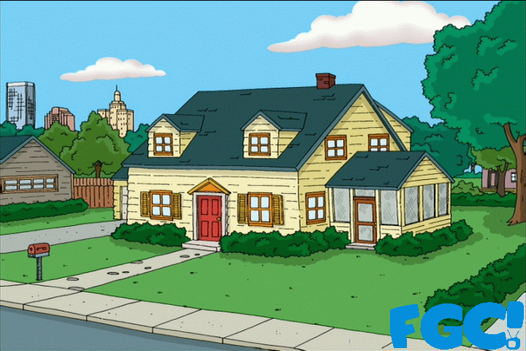

**B. Tick (✓) TRUE (T) or FALSE (F).**

**16 p**

**Correct only the FALSE statements.**

(S kljukico ✓ označi ali je trditev pravilna (T) ali napačna (F). Napačne popravi.)

**1.** The Griffins are a real family. T⭘ F⭘ _________________________________________________

**2.** Everybody likes Megan. T⭘ F⭘_____________________________________________________

**3.** The family lives in a flat. T⭘ F⭘_____________________________________________________

**4.** The sunroom is on the right side of the house. T⭘ F⭘ __________________________________

**5.** Peter always parks his car in the garage. T⭘ F⭘ _______________________________________

**6.** There are some roses in the garden.T⭘ F⭘___________________________________________

**7.** The Griffins’ house is big. T⭘ F⭘____________________________________________________

**8.** Thebathroom is on the 1st floor. T⭘ F⭘______________________________________________

**9.** Chris and Stewie share a room. T⭘ F⭘_______________________________________________

**10.** Stewie’s room is sometimes untidy. T⭘ F⭘ __________________________________________

**18 p**

**C. Answer the questions on the text in complete sentences.**

(Odgovori s celimi povedmi.)

**1.** How many boys do Lois and Peter have? ______________________________________________

_________________________________________________________________________________

**2.** What is Chris like? ________________________________________________________________

_________________________________________________________________________________

**3.** Who is Brian? ____________________________________________________________________

_________________________________________________________________________________

**4.** What’s the Griffins’ address? _______________________________________________________

_________________________________________________________________________________

**5.** How many windows are there? _____________________________________________________

_________________________________________________________________________________

**6.** Where does the family watch TV?________ ___________________________________________

_________________________________________________________________________________

download.jpghttp://images.clipart.com/thm/thm5/CL/STGR003/broder1-1a/alp29/alp34003.thm.jpg

**USE OF LANGUAGE**

**10 p**

**A. Look at the picture and complete with THERE IS/ISN’T/ARE/AREN’T.**

(Dopolni z **THERE IS/ISN’T/ARE/AREN’T.)**

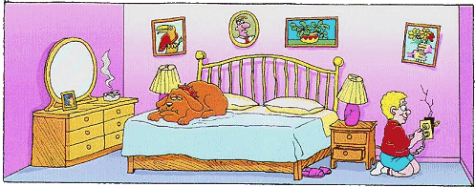

**1.** _____________________ a dog on the bed. **2.** _____________________ any windows.

**3.** _____________________ some pictures on the wall. **4.** _____________________ a TV set?

**5.** _____________________ two lamps. **6.** _____________________ a door.

**7.** _____________________ any books? **8.** _____________________ only one bed.

**9.** _____________________ a rug. **10.** ___________________ an alarm clock?

**B. Complete the text with the prepositions of place below and match the numbers with the pictures**.

**16 p**

Dopolni besedilo. Izbiraj med danimi predlogi pod besedilom.

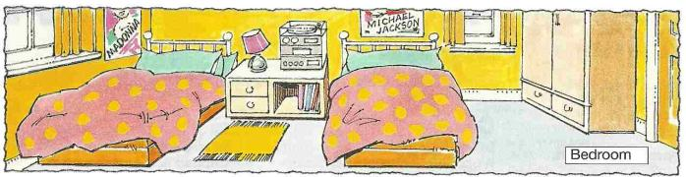

________________ of the bedroom there is a window (1). ________________ it is one of the beds (2). ________________ the beds is the bedside table (3). ________________ it is a lamp (4) and a stereo (5). ________________ the floor ________________ the bedside table is a rug (6). ________________ the right bed is a poster (7) ________________ the wall. Next to it is another window (8).

________________ of the bedroom is the door (9). ________________ it is the wardrobe (10). There is nobody ________________ the room.

on the right ⚫ on ⚫ beside (poleg) ⚫ under ⚫ over ⚫ between ⚫ in ⚫ in front of ⚫ on the left

**C. Label the pictures**.

**10 p**

(Zapiši besede za predmete na slikah.)



**5.**

**4.**

**3.**

**2.**

**1.**

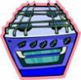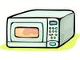

**10.**

**9.**

**8.**

**7.**

**6.**

**imagesCANLQSWP.jpg**

[](http://schools-demo.clipart.com/search/close-up?oid=880289&q=three&s=61&a=c&cid=&fic=0&k_mode=all&k_exc=&q_jpeg=1&q_gif=1&q_color=1&q_bw=1&q_eps=1&q_wmf=1&q_psd=1&q_png=1&date=&pubid=&isadv=1)

**WRITING**

**Describe this living room. Write about 10 sentences and don’t forget to say where things are.**

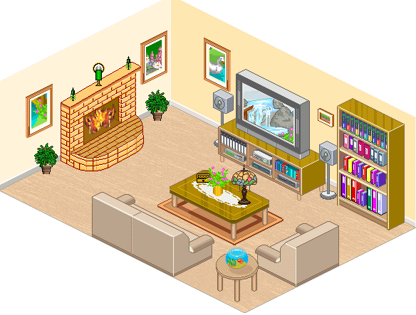 **(**Opiši dnevno sobo v 10 povedih. Napiši tudi kje je pohištvo v njej.)

**20 p**

______________________________

______________________________

______________________________

______________________________

______________________________

_________________________________________________________________

_________________________________________________________________

_________________________________________________________________

_________________________________________________________________

_________________________________________________________________

_________________________________________________________________

_________________________________________________________________

Če imaš težave besediščem in razumevanjem, si pomagaj s spletnim slovarjem:

https://sl.pons.com

Pri učenju predlogov ti lahko pomaga tudi ta video:

<https://www.youtube.com/watch?v=QYerFOnPxu8>

Pričakujem, da boš te naloge naredil do petka.